**Increment 4 documentation on**

**Remind me!!**

**A SMART WAY TO LIVE IS TO REMEMBER REMIND ME!!**

**Objectives:**

To develop an android app to manage and remember all your daily shopping and Journey needs. This application provides a way to set voice reminder. We provided 3 different tabs. Once the user logs in with his credentials, the user gets directed to a page where he can set reminder to shopping or journey. We provided about tab where new user can get information about different tabs. Once the user sets the reminder, he gets a user defined voice message which can be set different for different reminders as chosen by the user.

Our goal is to provide an application which can be used by everyone in his daily activities.

**Import Existing Services/API:**

**Name:** Google Maps API.

**Description:** this API is used to set the exact address, it is used both in Journey and Shopping tabs..

**URL:** <https://developers.google.com/maps/documentation/javascript/tutorial>

**Name:** Walmart API

**Description:** For finding the details of the items present in the Walmart store , we used this API.

**URL:** <https://developer.walmartlabs.com/docs>

**Detailed design of services:**

***Service description:***

we developed a reminder application where we provided user with 3 different tabs,

1. Shopping tab
2. Journey tab
3. About tab

Here each of the three main tabs directs to their corresponding functions tab page. Once the user logs in, he has the option to set reminders for 2 different uses.

***Shopping tab:***

We have done this in increment-2.

Where user has the options to set address, date and time and also by providing the list of items he wants to buy. User is provided to set a user defined voice message.

***Journey tab:***

We implemented this in increment-3.

Here user has the option to set reminder to his journey, he can also provide details about the intermediate halts in the journey with time and date. Once the user updated the details about his journey, user has to press *Start button* to start the reminder and *stop button* to stop the application.

We added additional features to the application for increment 4.

1. ***Password encryption:***  we are using the encryption technique to encrypt password when the user sign up and I sock it (the password) crypted and send it to the database. So using this even the database admin cannot know the exact password except the user.

For this we used a hash function, SHA-2, like any hash function, it gives you as a output a fixed length string, whatever was the length of your password, the hash is 256 bits length. And it is a strong hash not like SHA-1 or MD5 or any other one.

1. In the shopping tab, we added feature to set the time also used Google maps API , to provide exact location of the store
2. In the journey tab, we added more features like the user can provide exact location of the source, destination and halts.
3. We added description about out app briefly in the about tab, which aids the new users to know about our application.

For selecting the address using the maps, after entering the address in the search box, the user has to click on the marker to add the location.

**SCRUMDO Screen Shits:**

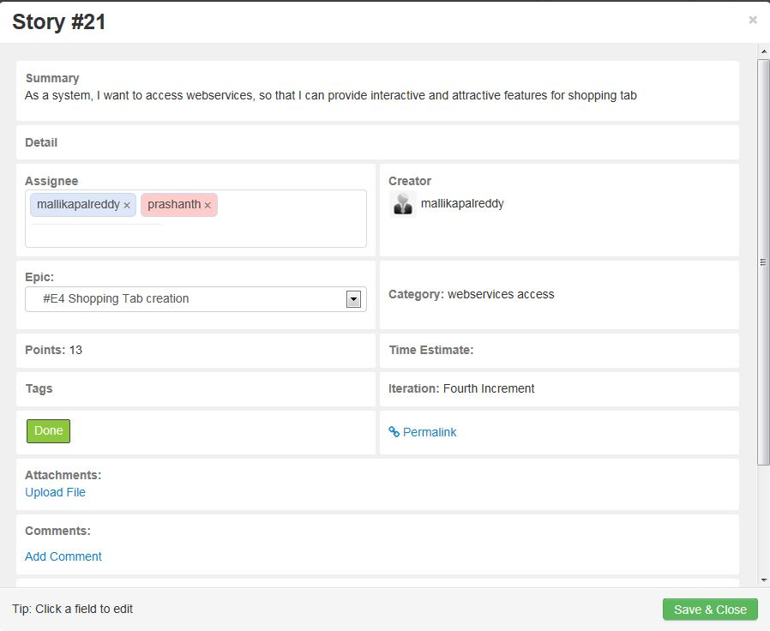

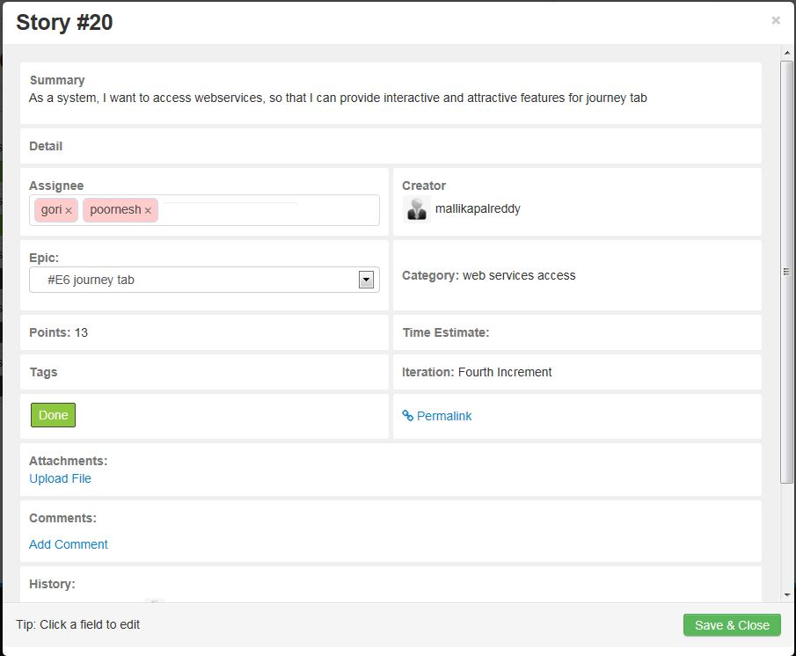

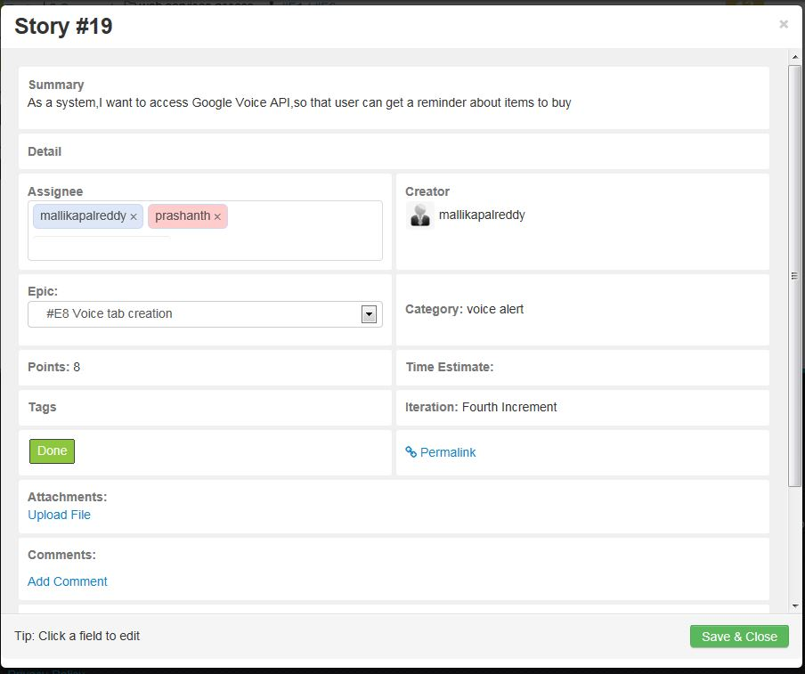

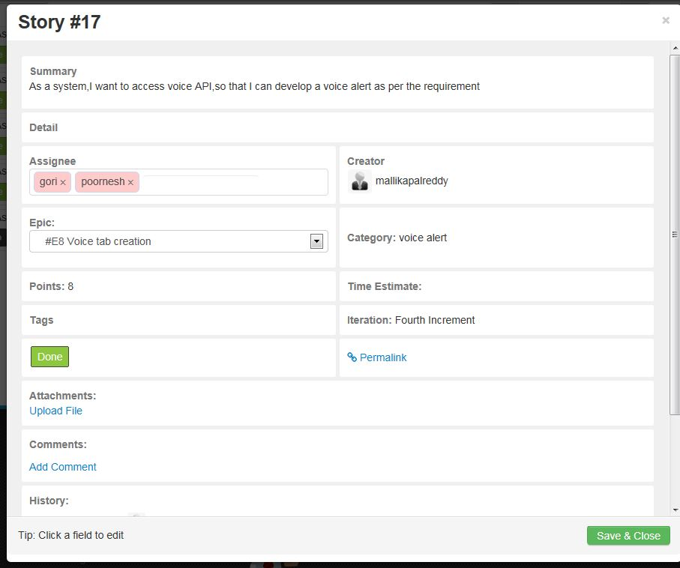

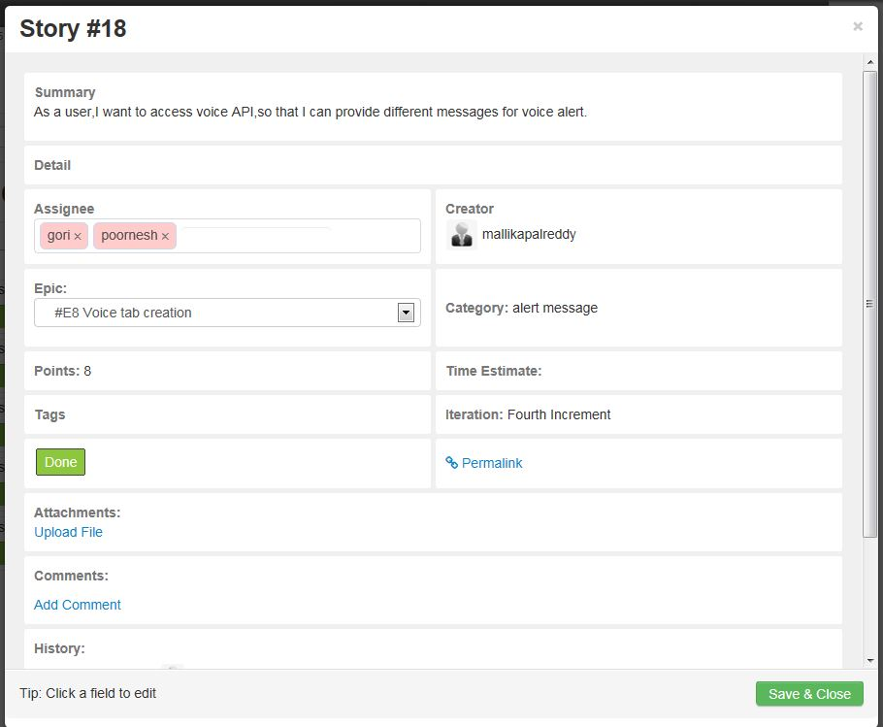

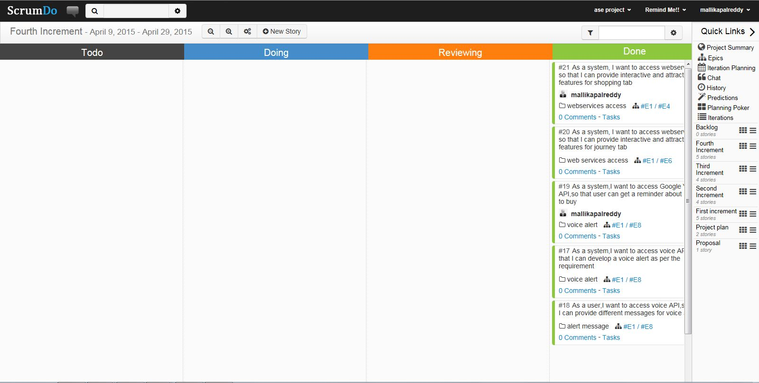

**Architecture:**

We are using My SQL database to store the data, Walmart and Google API’s to access the data provided by them. In our app once the user enters the data the server contacts SQL database using advanced rest client services.

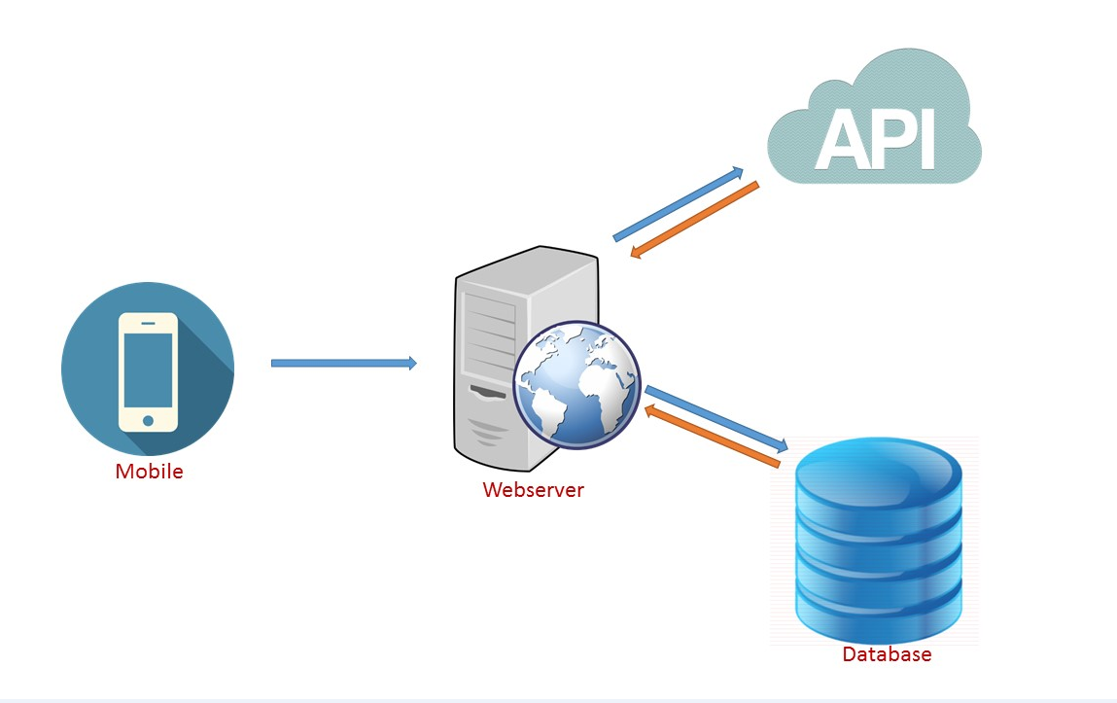

**Class Diagrams:**

**Class Diagrams:**

**Login Page**

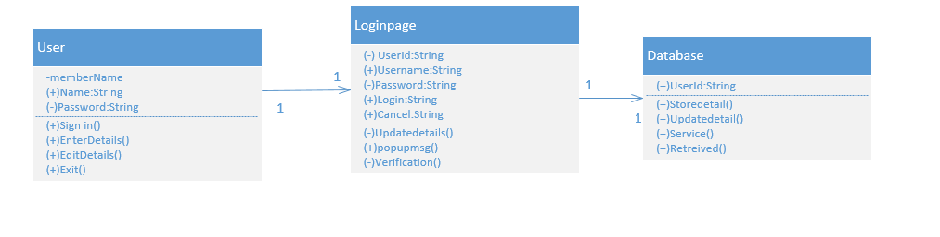

**Registration Page**



**Shopping tab:**

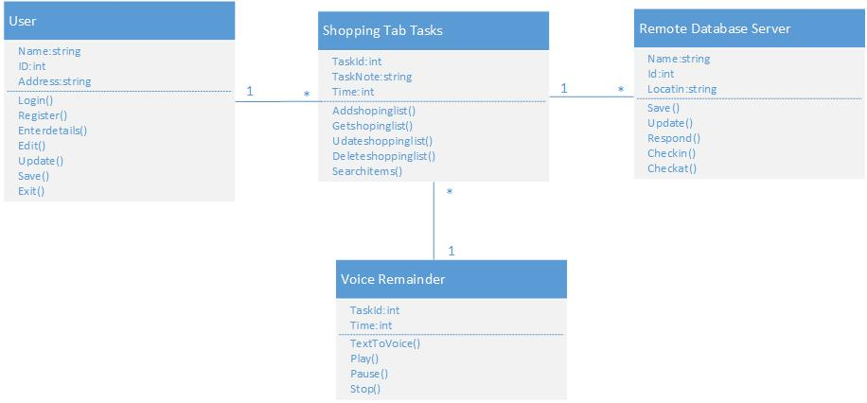

**Journey tab**

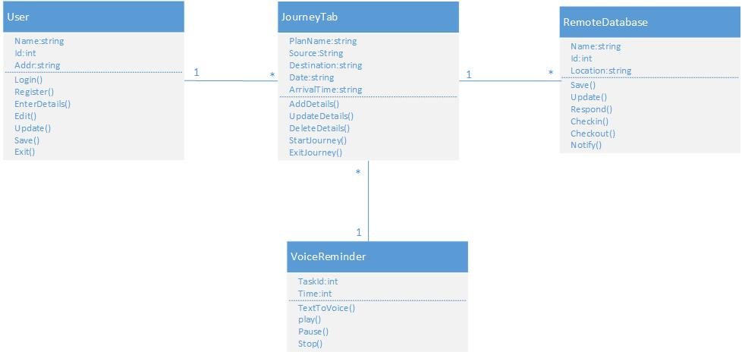

**Sequence Diagram:**

**Login Page**



**Registration Page**



**Shopping tab**

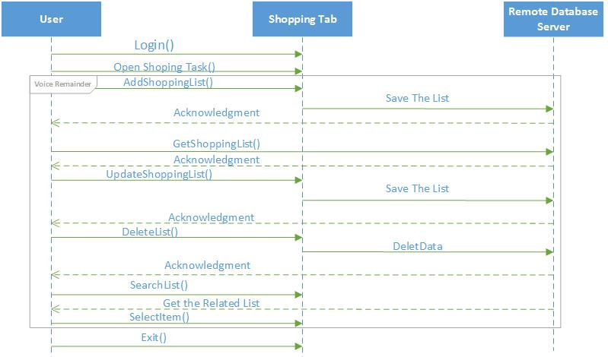

**Journey tab:**

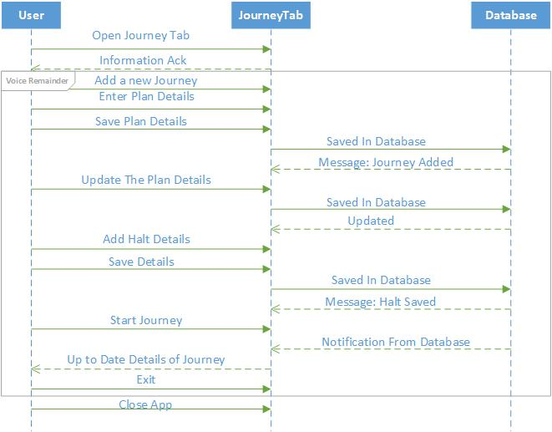

**Design of mobile client interface:**

**App Icon on Mobile:**

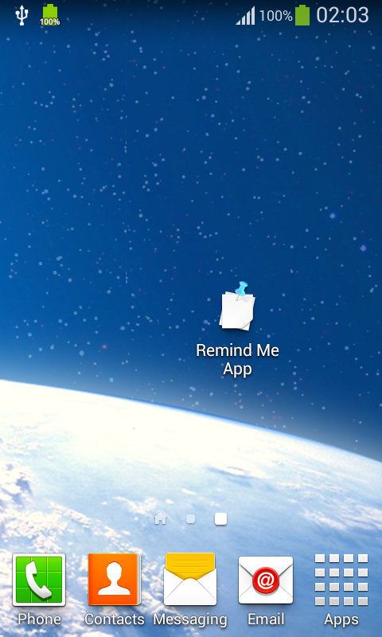

**Login Interface:**

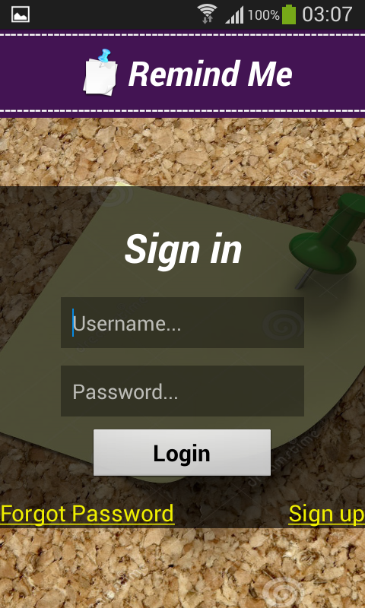 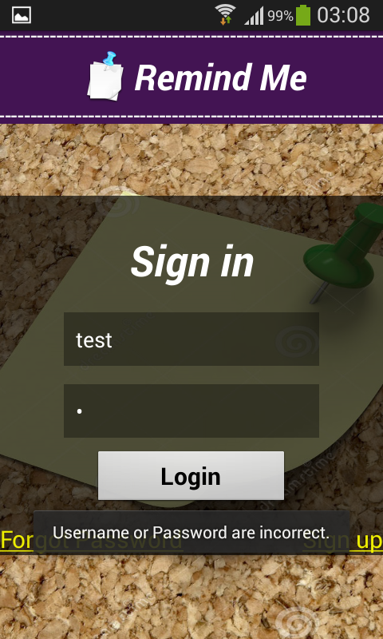 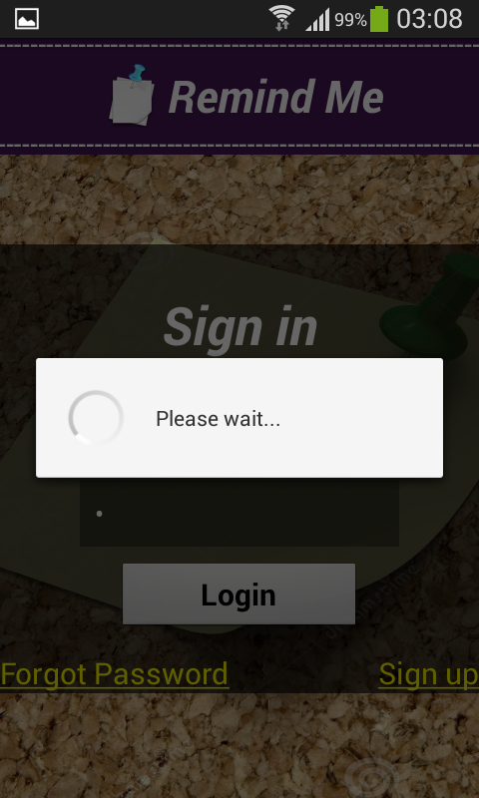

**Register Interface:**

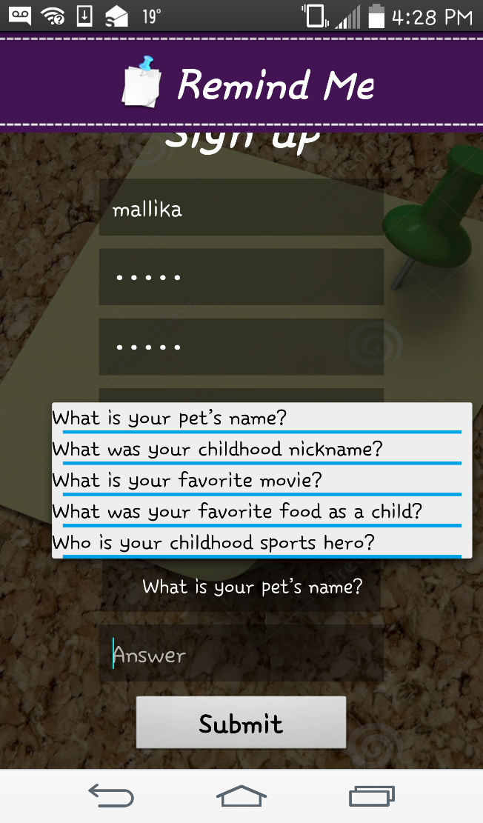

**Shopping Tab Interface:**

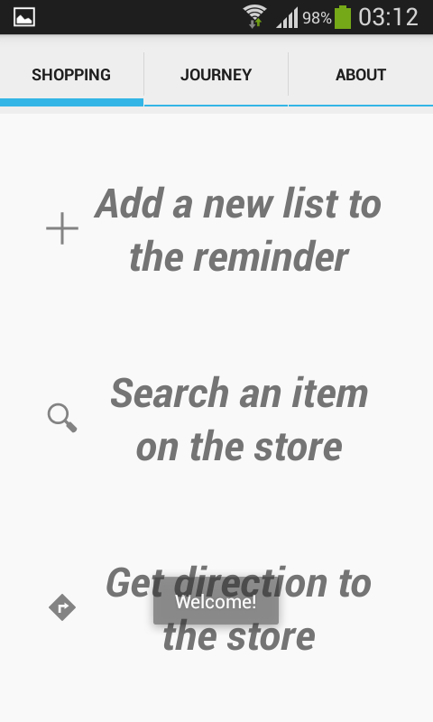 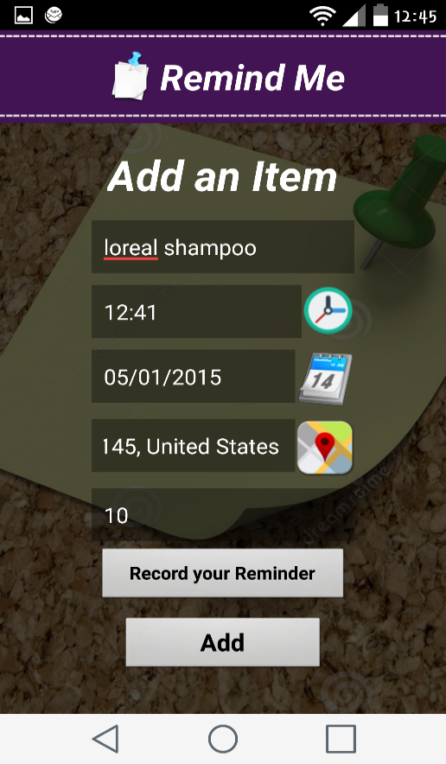

**The main shopping tab contains the three services available.**

**Each service has update and delete functionality upon requirement.**

**The user can record their own voice reminder by choosing the record option at the end.**

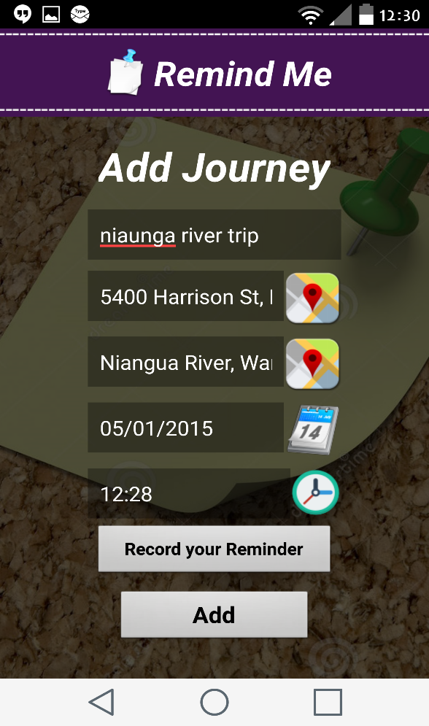**Journey interface:**

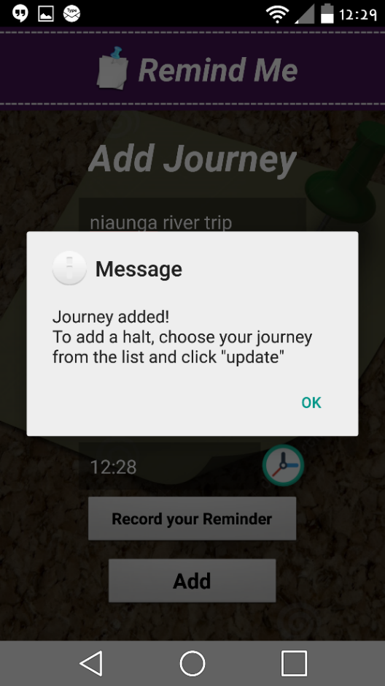

1. Displaying lists of journeys added

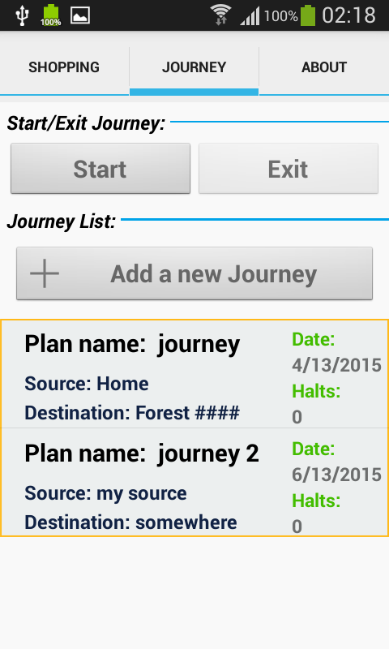

On click of journey added, here we have 3 options to select

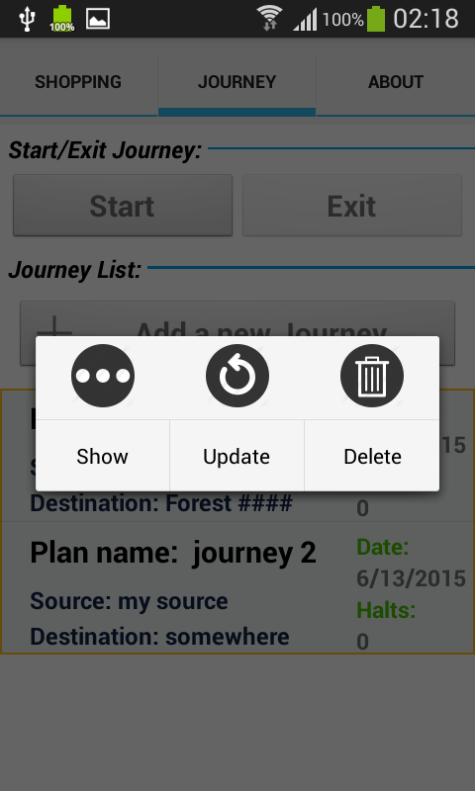

To update the journey, click on update. The below page will be displayed.

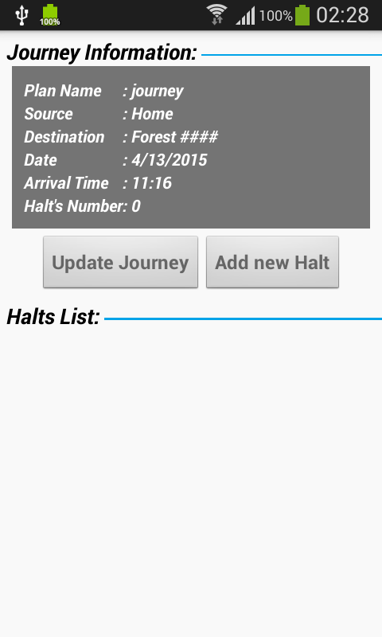

Here, we have 2 options:

1. To update the journey
2. To add halts to the journey

If we select update journey the below page appears,

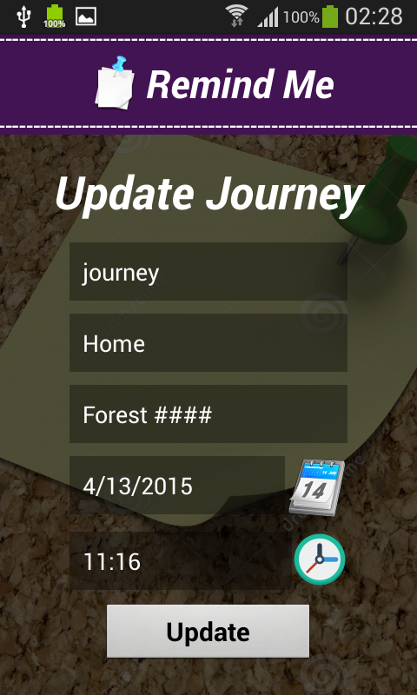

This page displays, when we want to set the time.

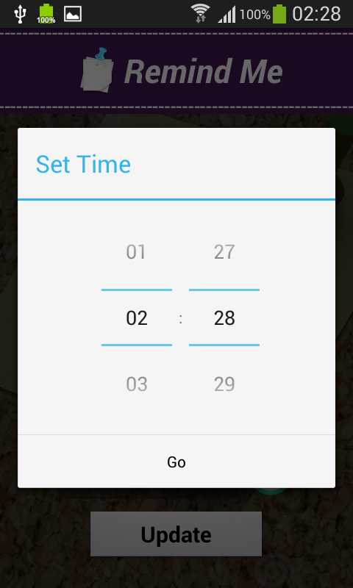

This page appears after successfully updating journey.

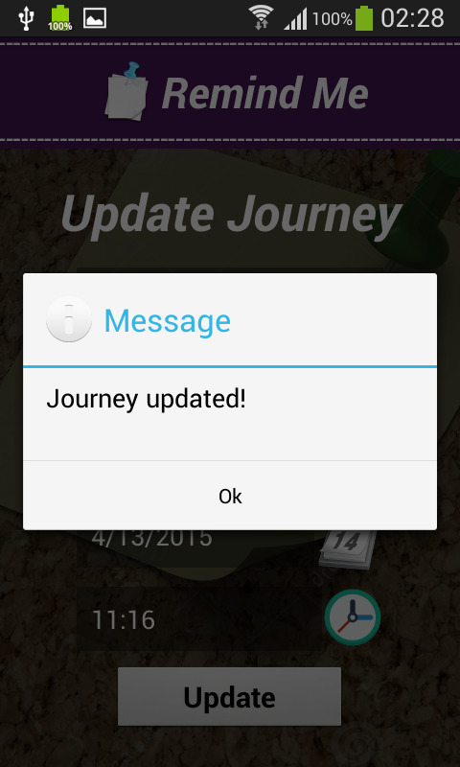

If we select option2: add halts, the below page appears

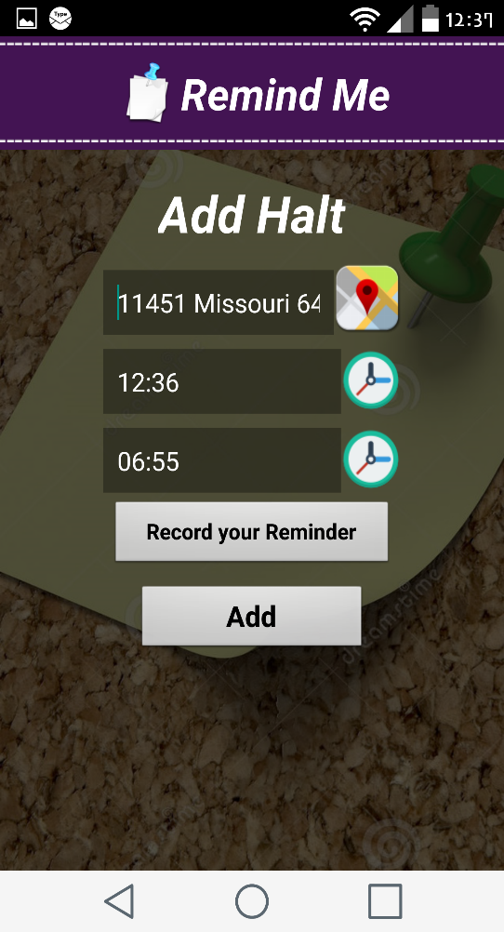

Message after successfully adding halt

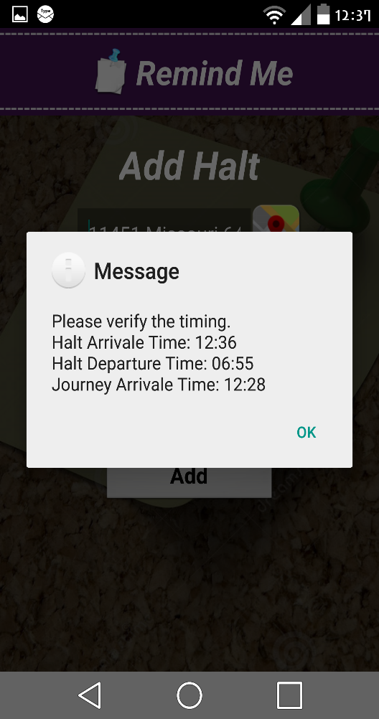

Once we are done with adding the journey, we have to click start button to start the application

**Implementation of mobile client interface:**

**Implementation of REST Services:**

We used My SQL database with advanced rest client services using Jersey framework in java.

**Implementation of User Interface:**

**Login Page:** Below are the features we added for the login page.

For the first time user, he has to sign up by entering his details. Once he enters all the details and registered, he can log in into the app.

We also provided the user with forgot password, where he gets directed to the security question if he correctly enters the username.

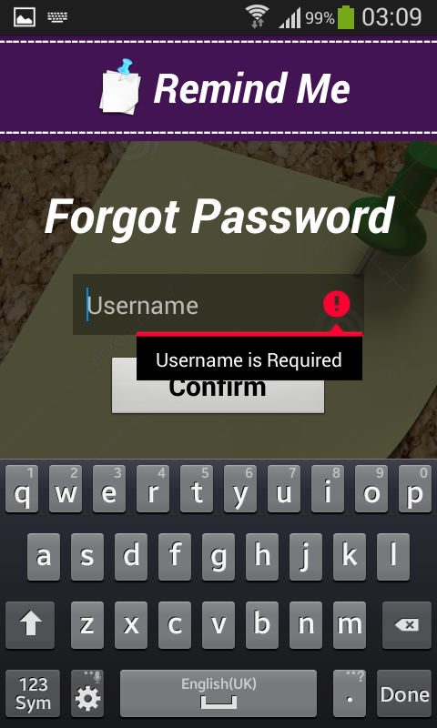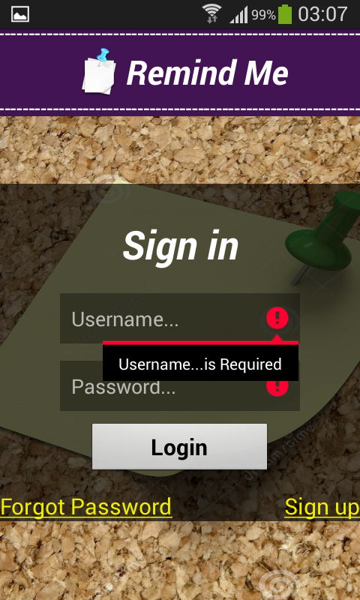 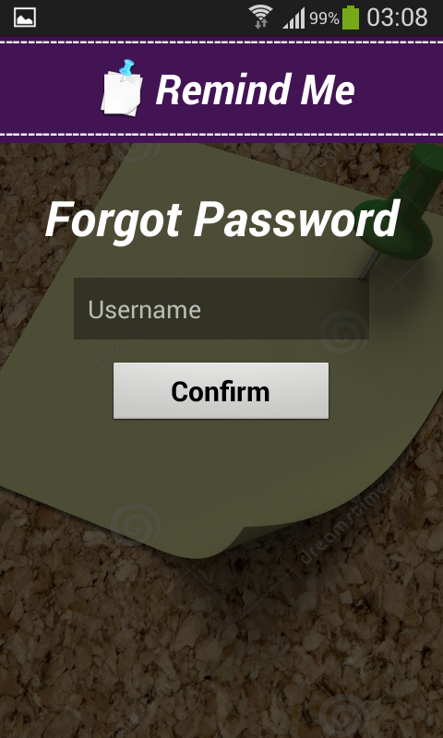

**Implementation of Register Page:**

**Registration Page:** Once the user selects the Registration tab, the user s directed to this page, where he enters his details for registration.

The user can get registered successfully if the user enters different password and confirm password, and a popup message saying “Passwords doesn’t match” will appear.

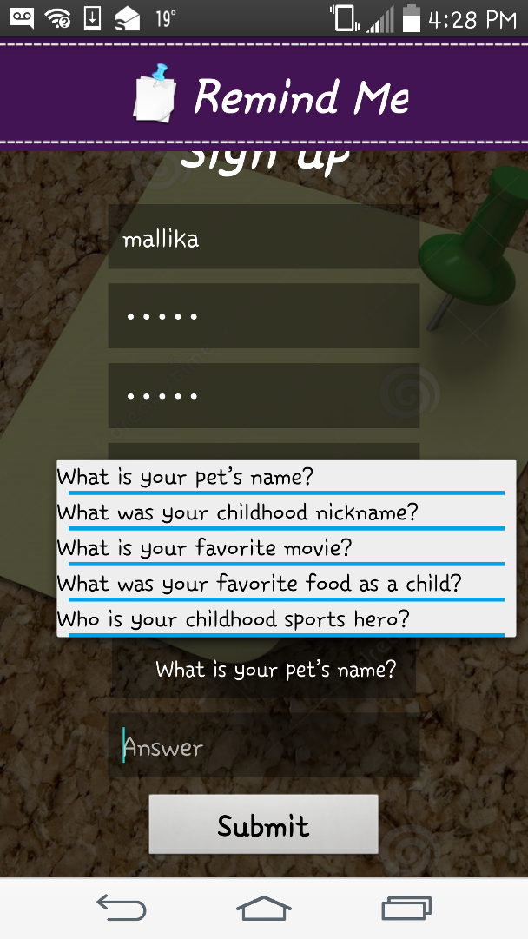

**Implementation of Shopping Tab:**

In the implementation of shopping tab we have 3 sub tabs.

1. Add a new list to the reminder

2. Search item on the store.

3. Get directions to the store.

In first subtab it is directed to page having ADD A NEW ITEM where we can give the item details like price, address of the store and set reminder at the same place by providing the date and time for the item.

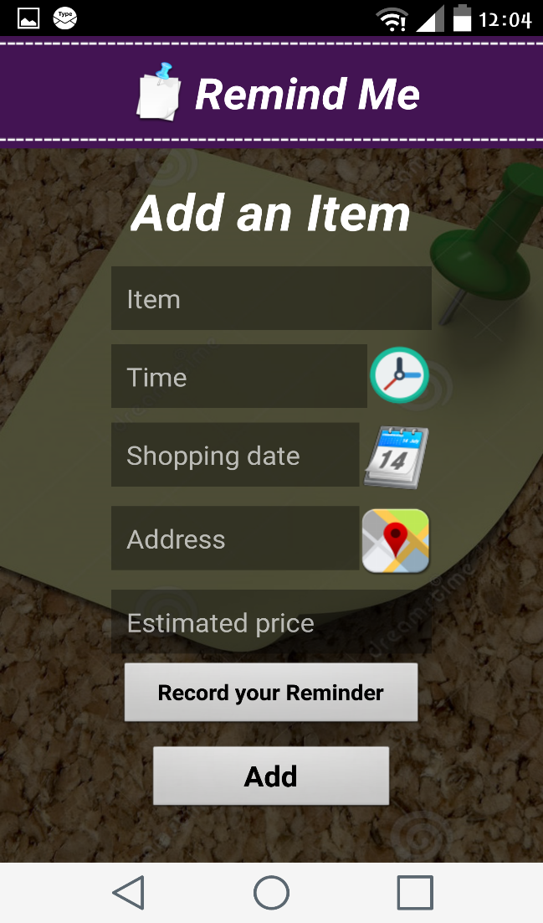 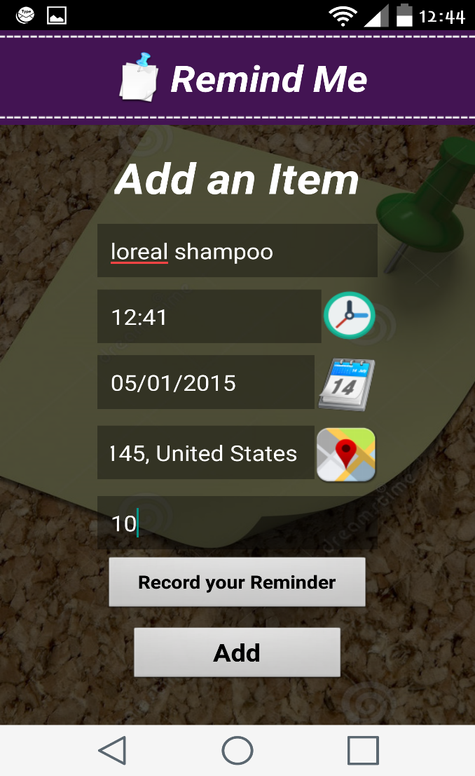

Here after giving the details for each field a voice recording for the voice alert can be given by using the Record your reminder option in the bottom of the page.

The below windows show the list of reminders in the shopping tab.

The user can read the details of the reminder by selecting appropriate reminder and then selecting the read option.

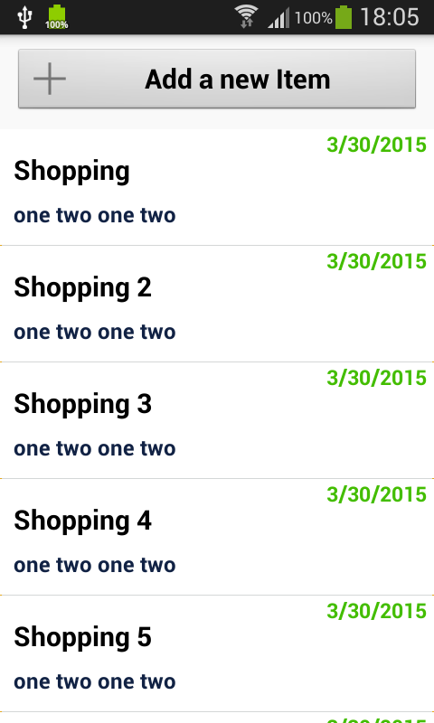 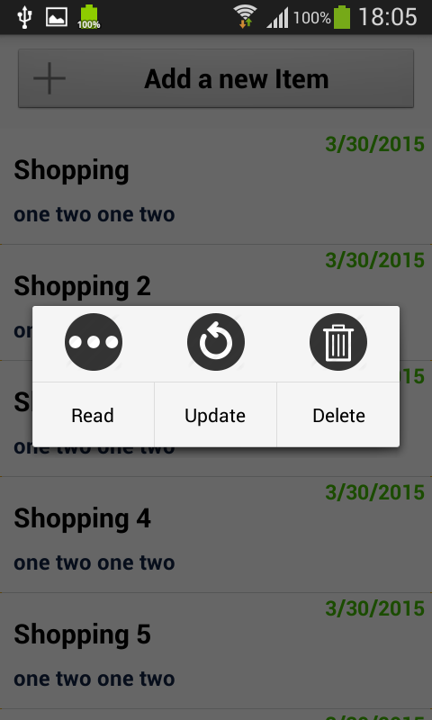

The user has an option to update and also delete the reminder set by selecting the appropriate reminder and then update/delete option respectively.

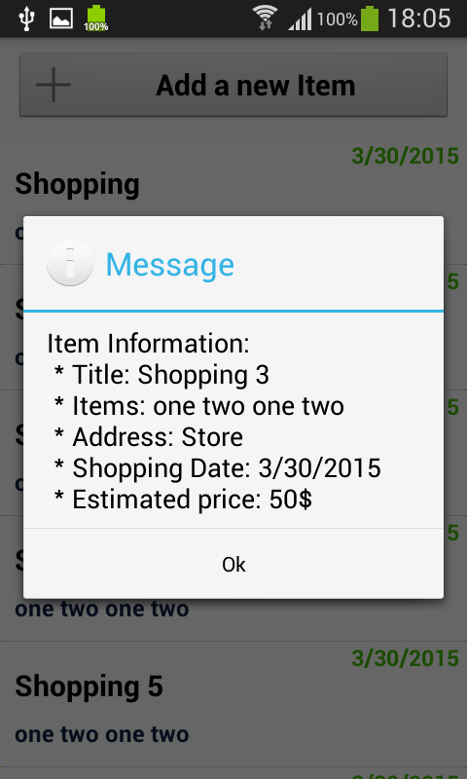 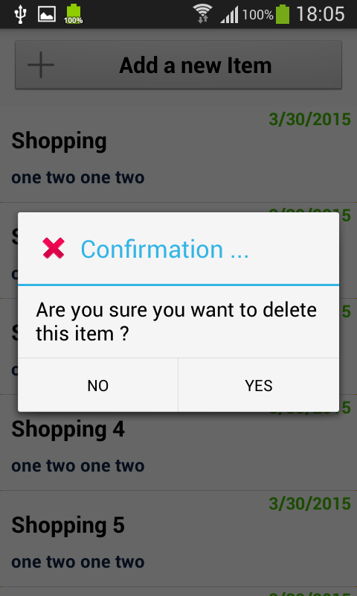

**The above windows show the Message alert and confirmation alerts respectively when read and delete options are selected respectively.**

**Implementation of Search Service:**

**In the search for store service that is**

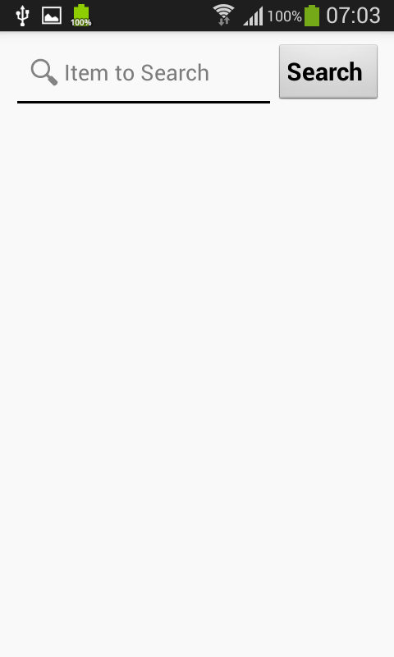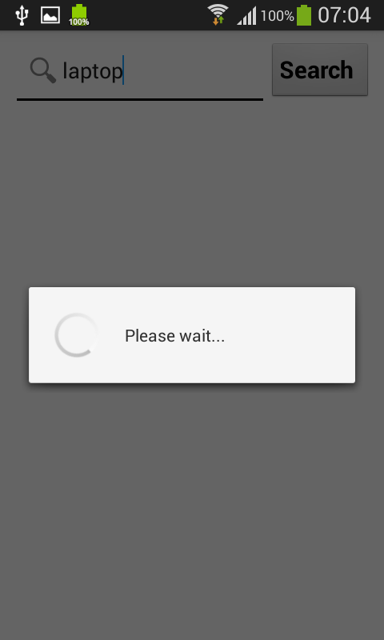

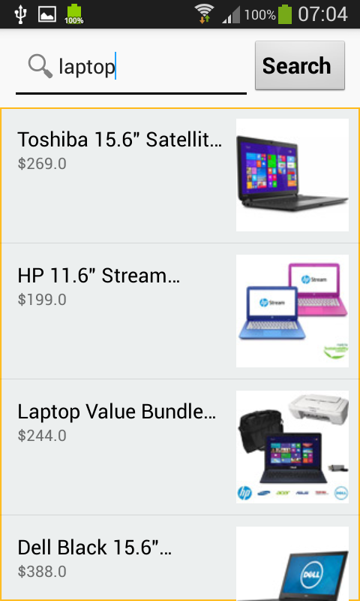 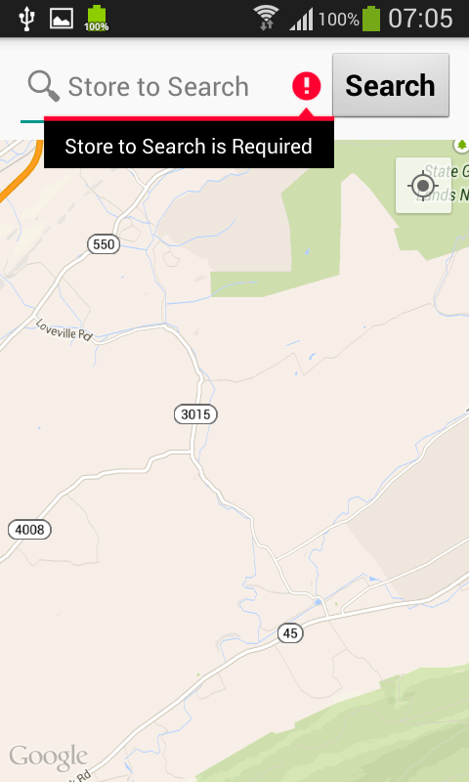

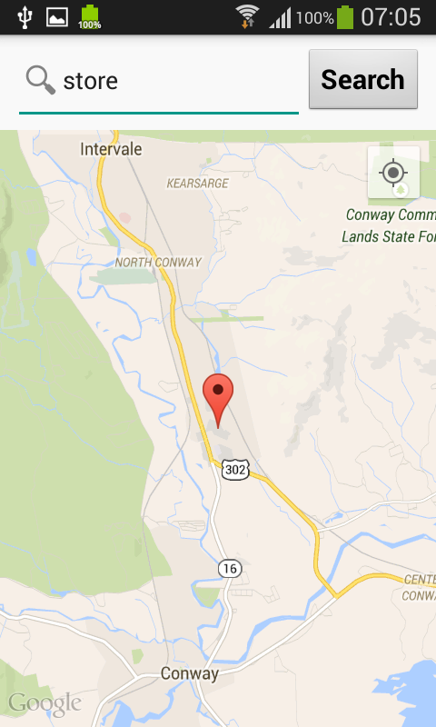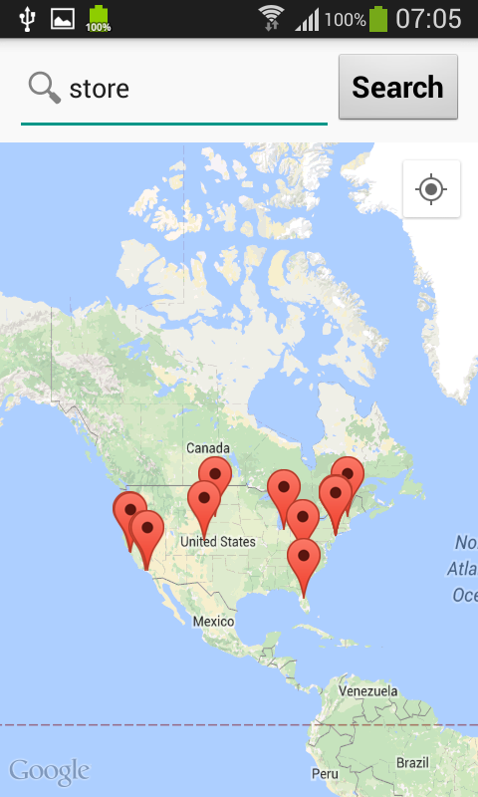

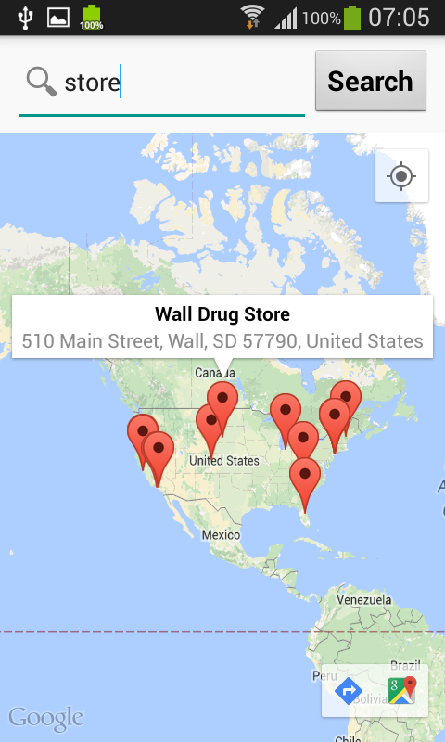

**Journey tab:**

**Step 1:**  This is the view of the journey tab with list of journey’s added



**Step 2:**

If we select add journey button, the below page appears

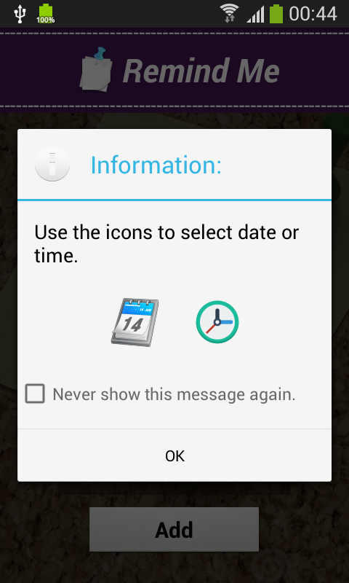 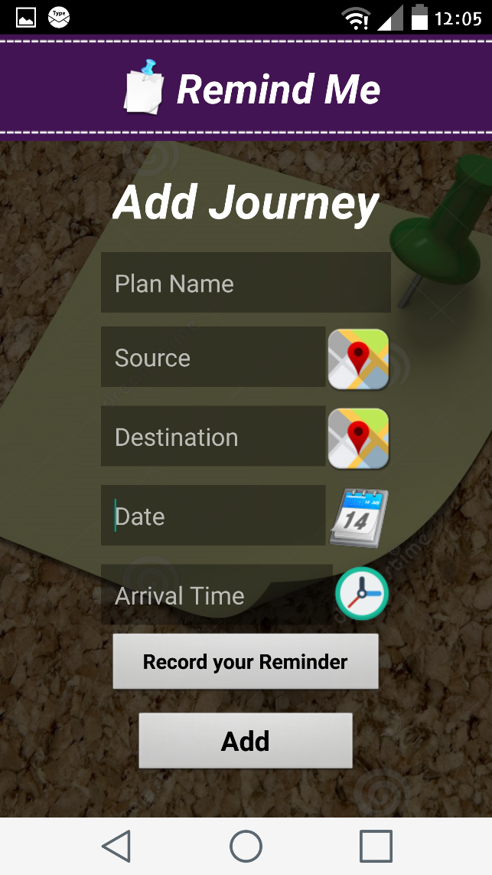

**Step 3:**

All the details of the journey should be provided in the below page, it shows error if the user misses to provide any details as shown,

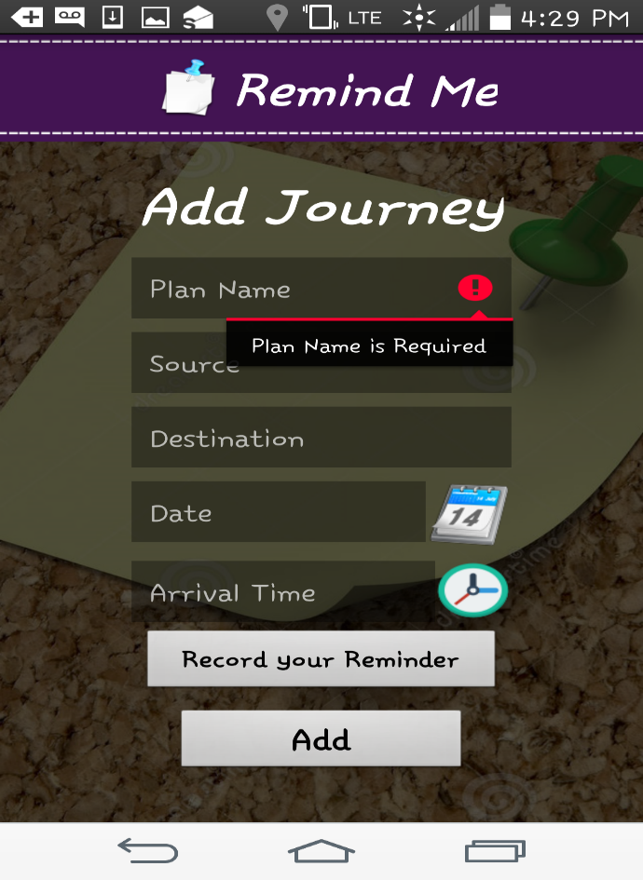

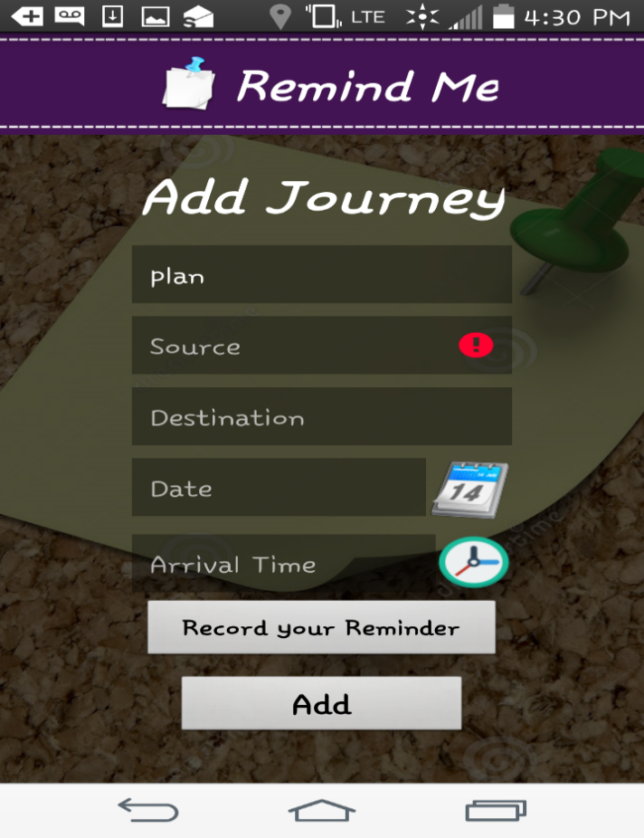

If the source details are not provided, it shows an error as shown in the adjacent screenshot

**Step 4:**

If the user doesn’t enter the destination or date details, it shows error as below

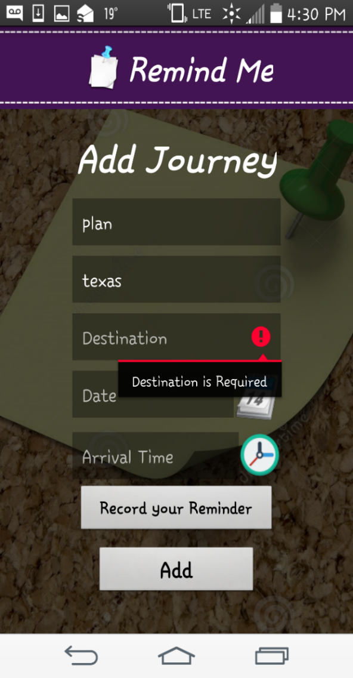 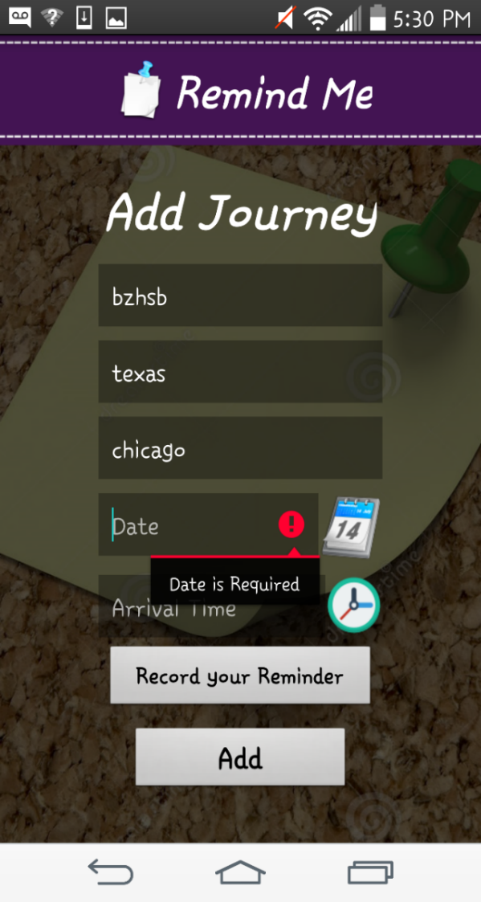

**Step 5:**

By selecting calendar, the user can provide the date details

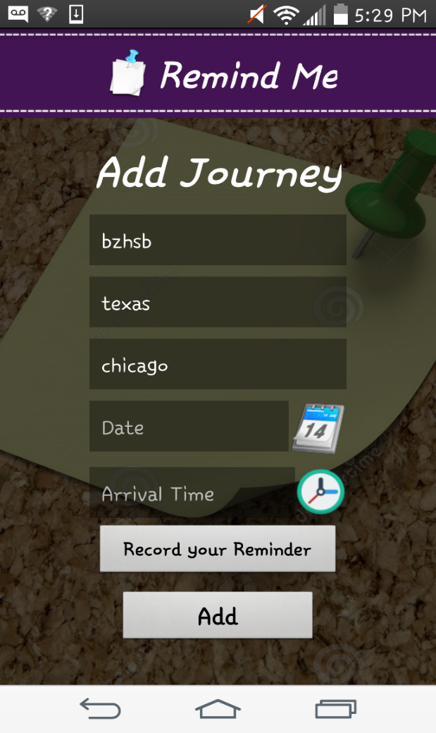 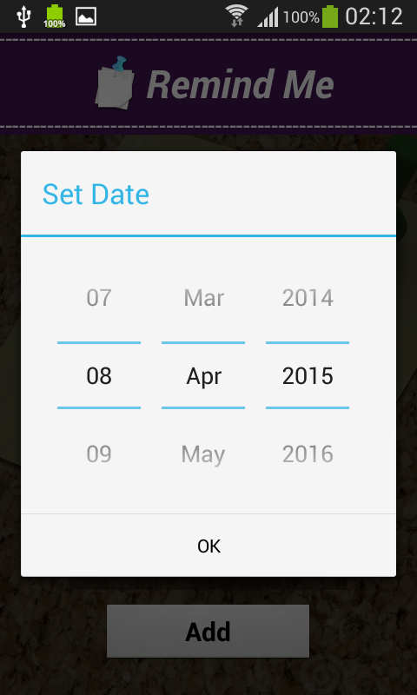

**Step 6:**

If the user selects time with all other details, the below pages will appear

 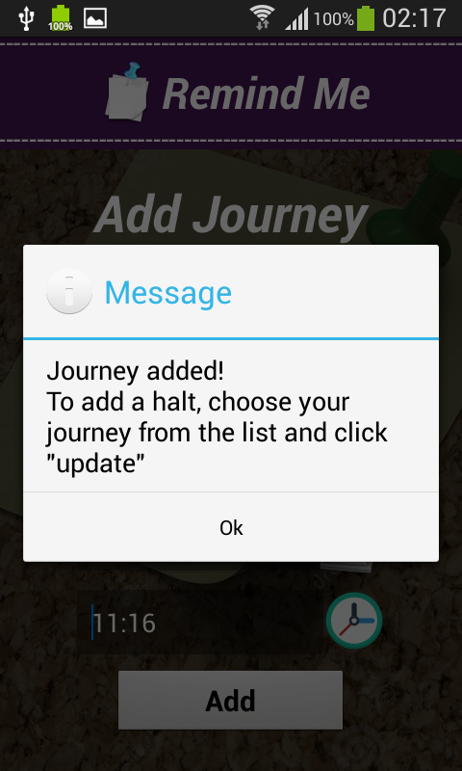

**Step 7:**

In order to add halt, the user has to select add halt button and the below page appears

 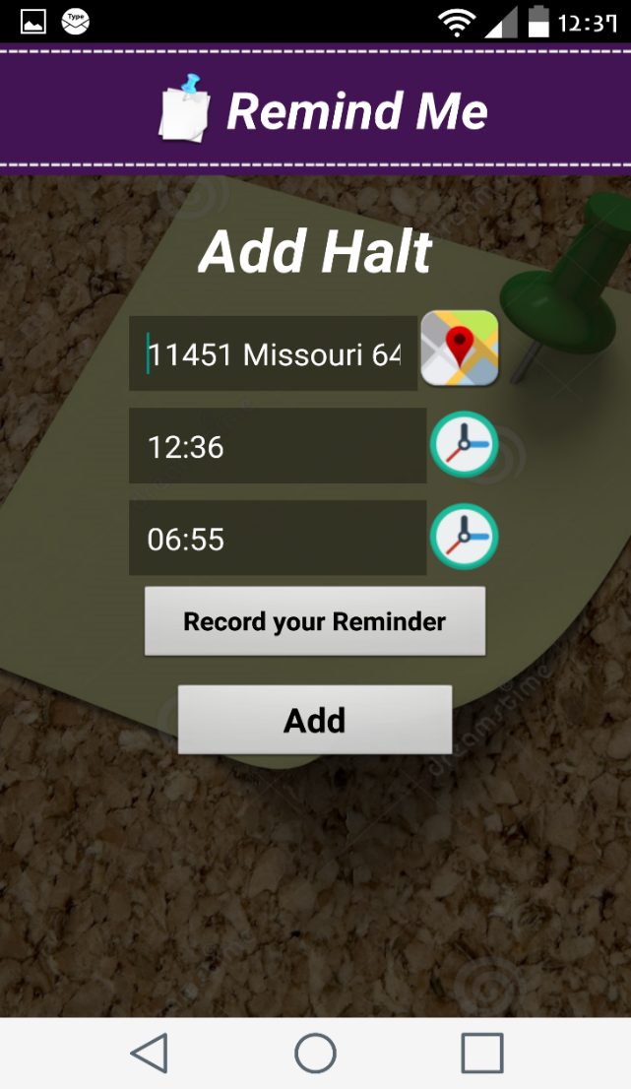

Similar to add journey, the user has to enter all the details to add the halt.

**Step 8:**

.the user has to enter user defined voice message, for each and reminder else it shows an error as shown below.

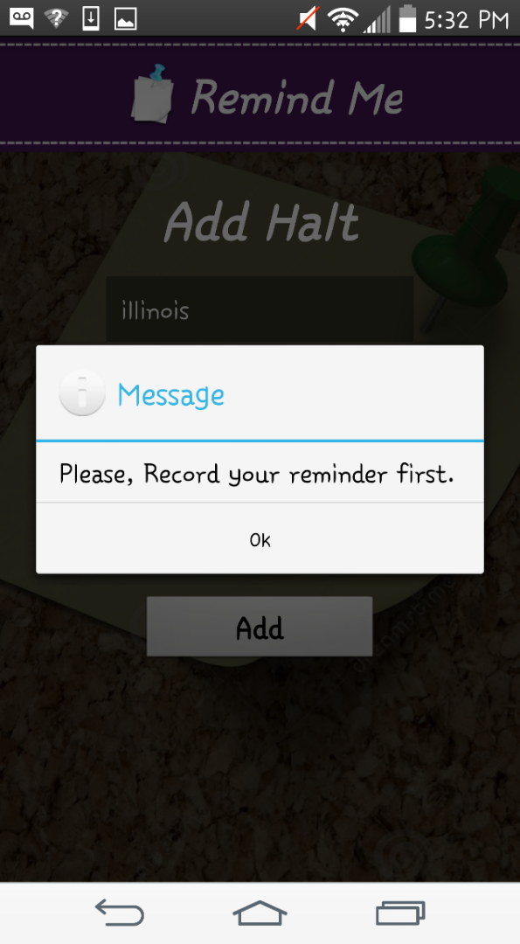 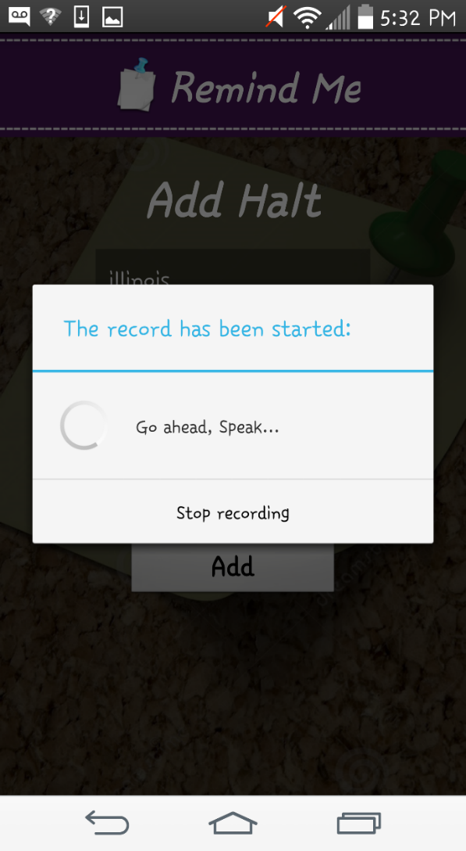

**Step 9:**

After adding halt successfully, the below message appears.

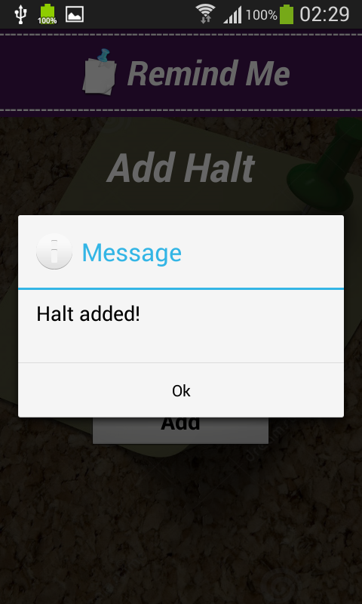

**Step 10:**

If the user wants to update the journey, the he can select the update journey and change the details as needed.

 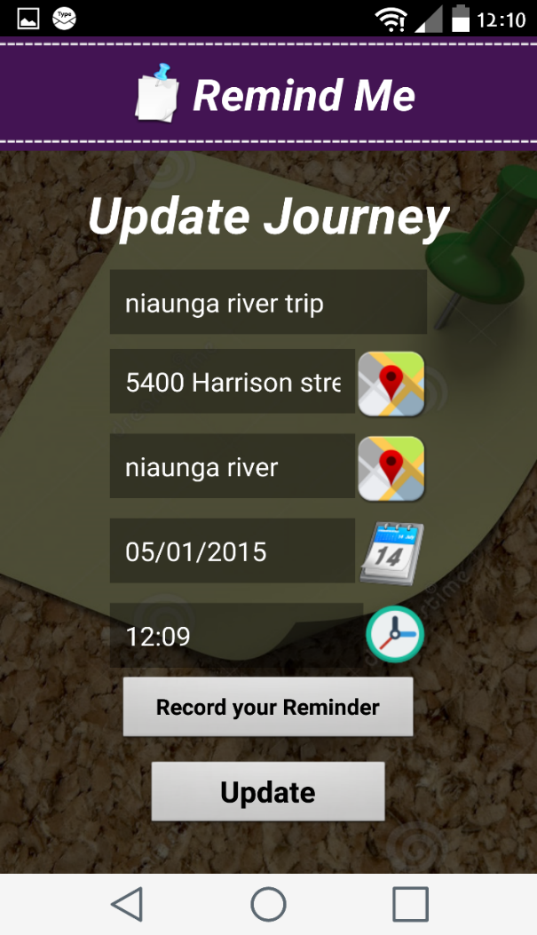  
  
**Step 11:**

the below message appears after updating the journey successfully, same with the halt services.

 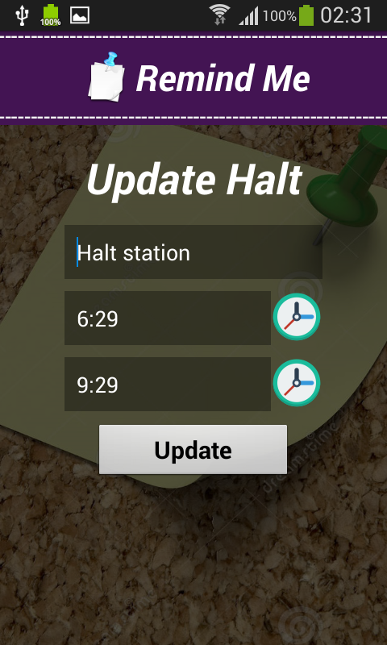

.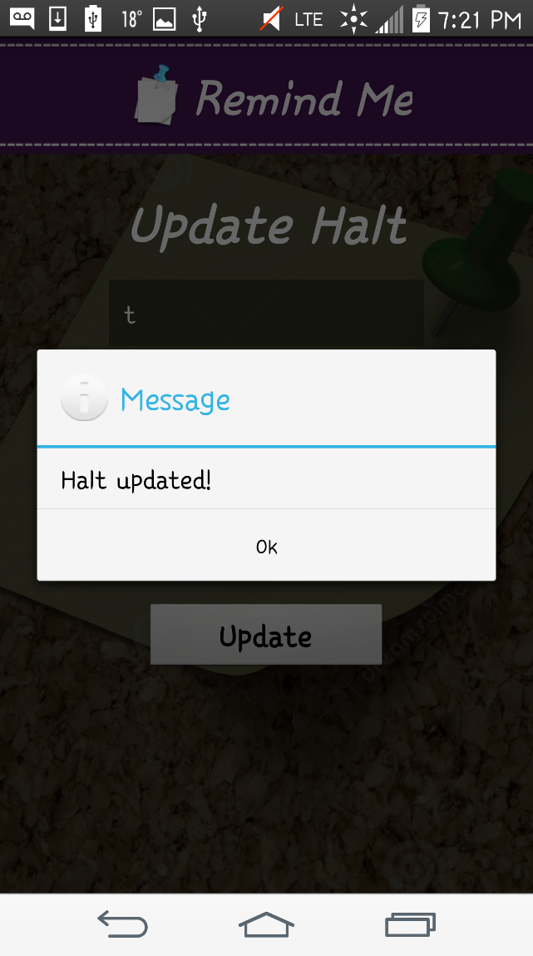 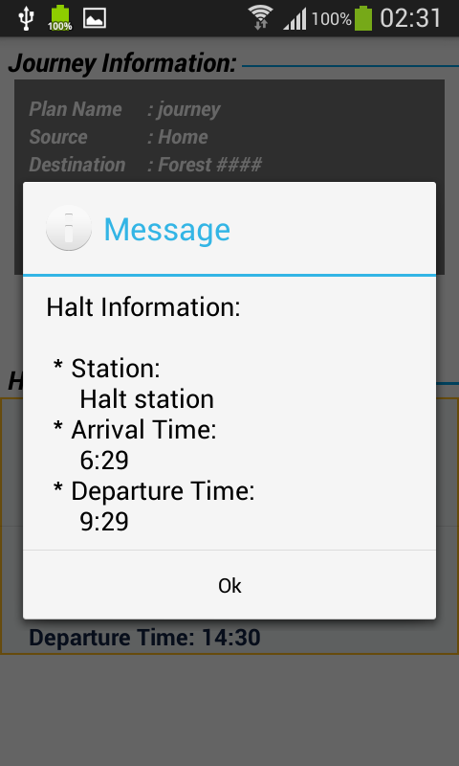

After updating the halt, the message as shown appears .

**Step 12:**

To get the details of the journey, the user can click on the show button.



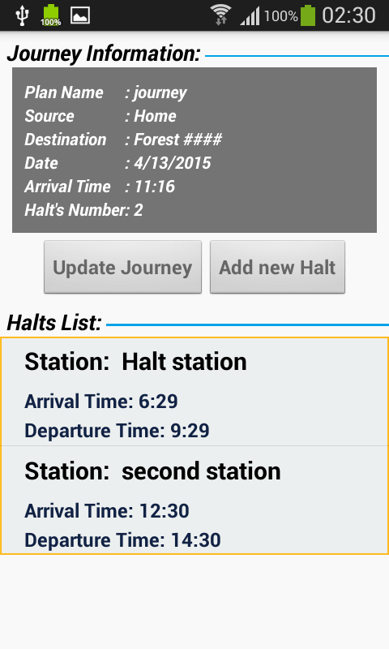

**Step 13:**

Similarly, if the user wants to delete any journey or halt he can do that as shown below

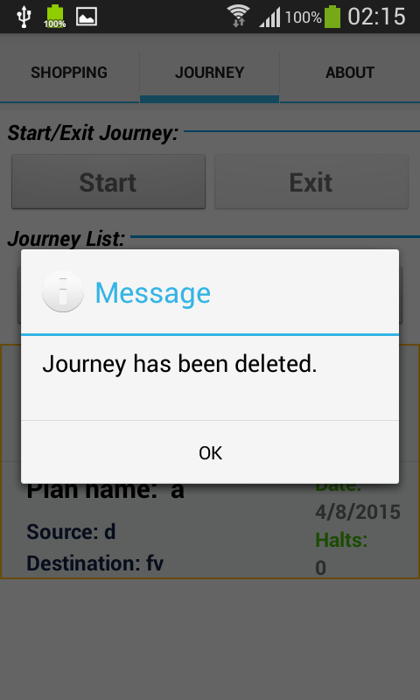

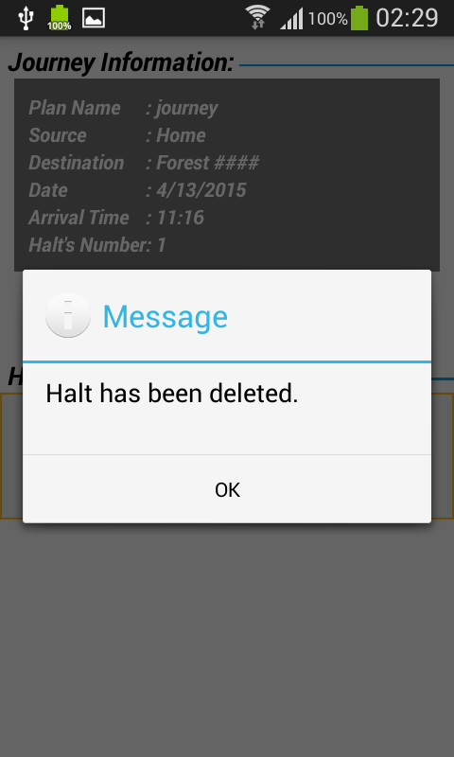

**Step 14:**

Once the user is ready and everything is done by providing the details the reminder is set and ready and the following window is displayed.

The notification of the alert is shown in the adjacent window as shown.

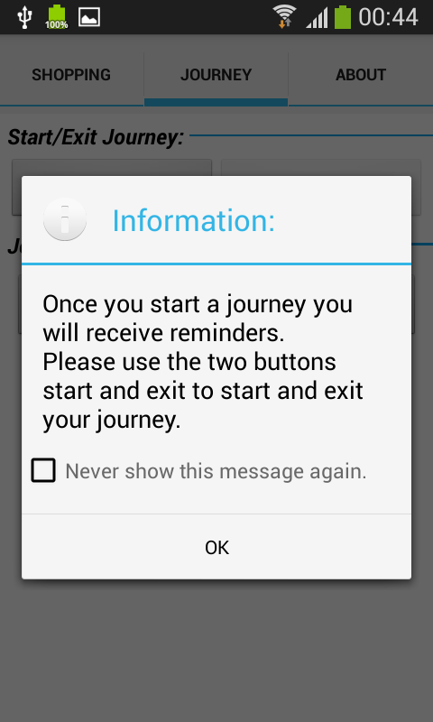 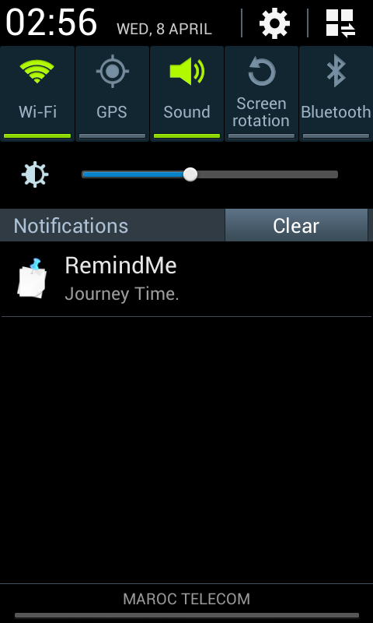

**Step 15**: If the user wants to terminate or start and exit for journey tab, it can be done as follows.

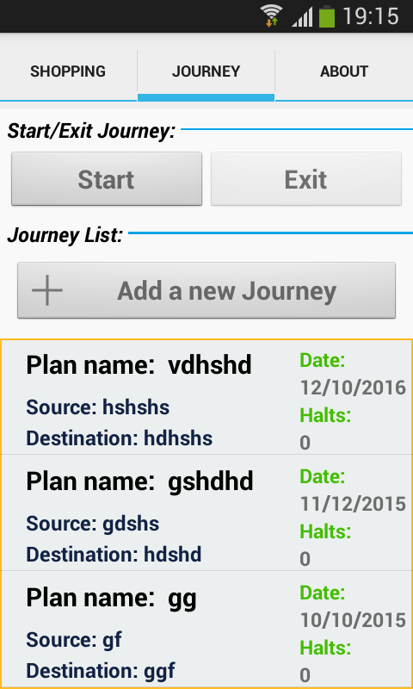 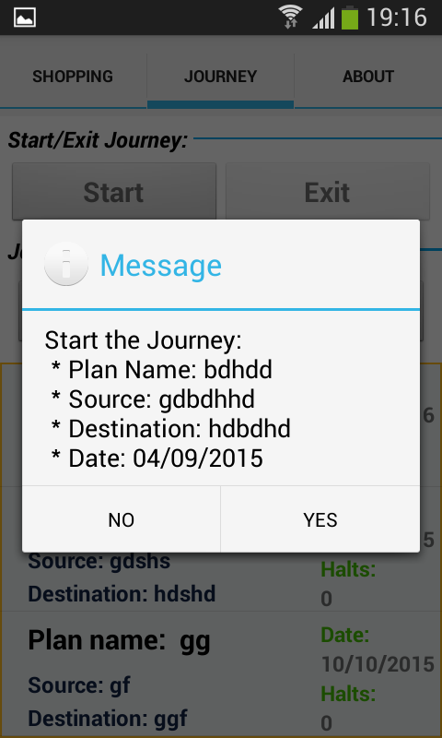

**Step 16:**

To start the journey application, the user has to click stop button, he gets a confirmation message as shown below.

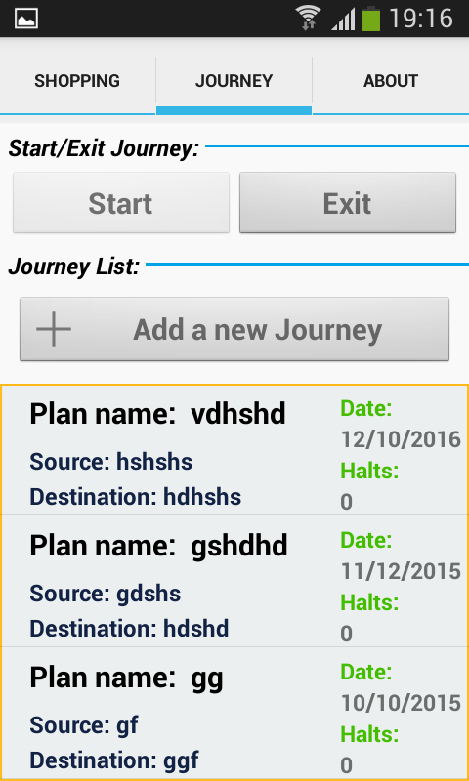 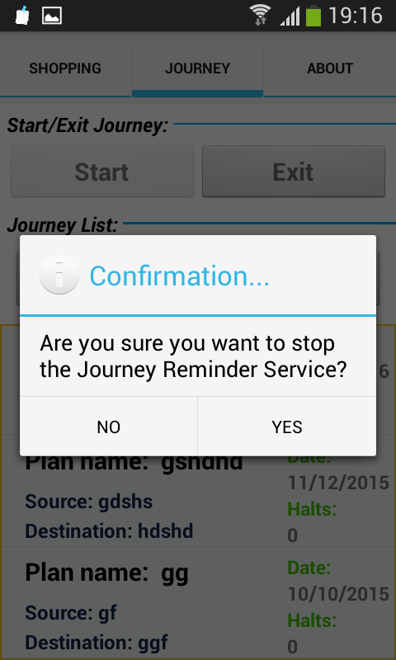

**Testing:**

Testing is done using Advanced Rest Client Services.

We are this testing as we have get, post methods and we get the reply instantly in json format.

**Login tab:**

login failed

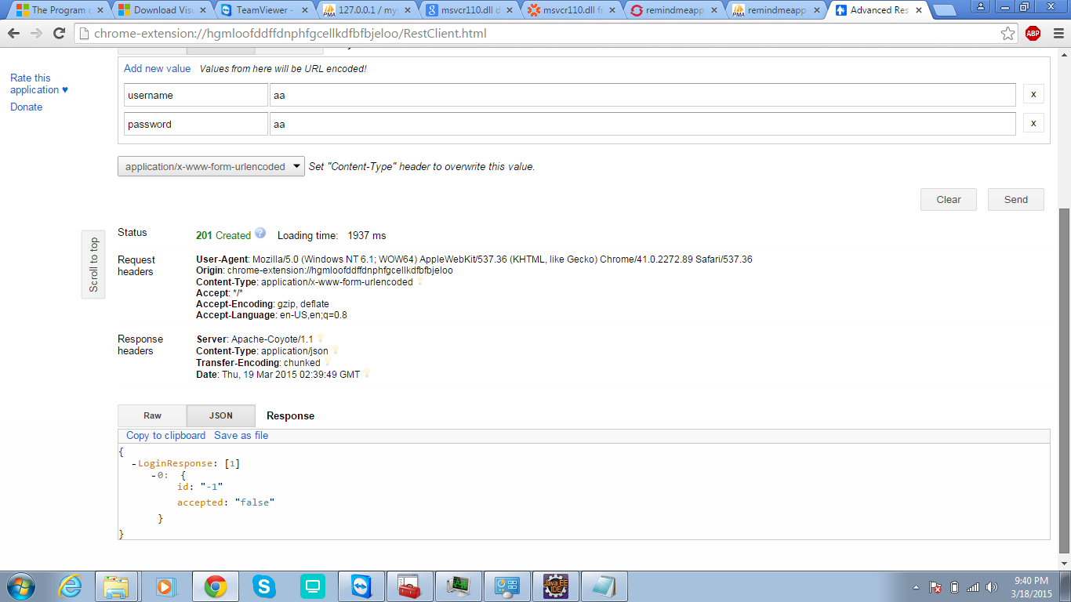

Login successful

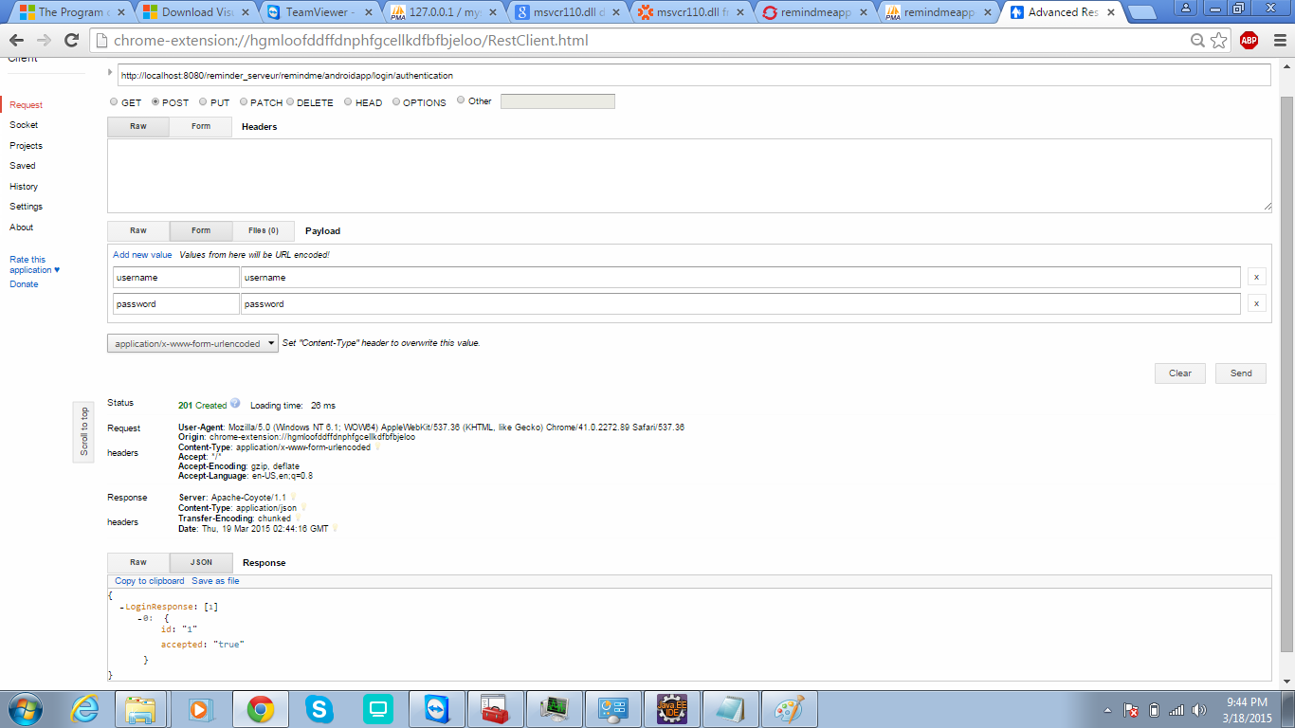

Sigining up- successful

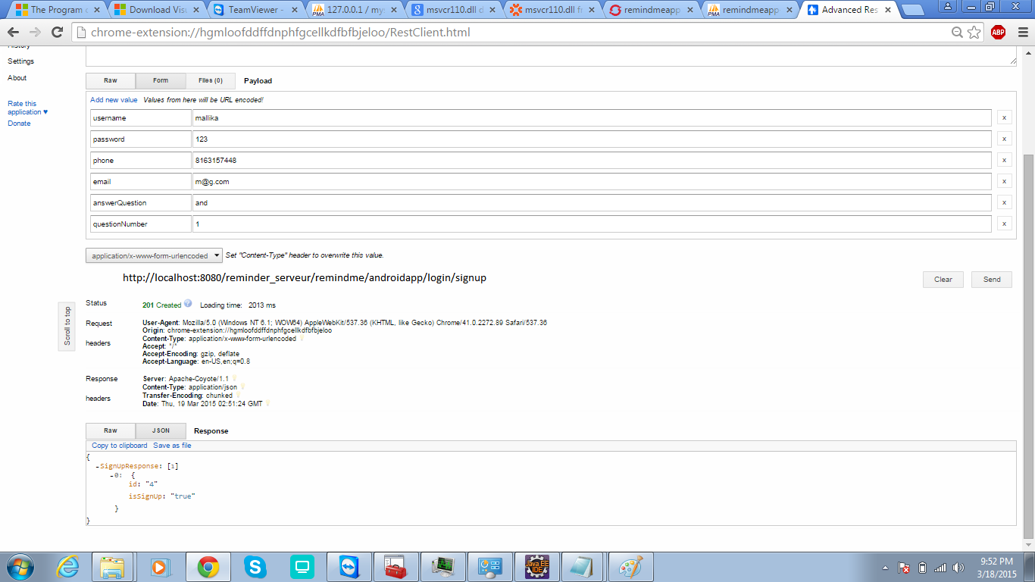

Signing up - failed

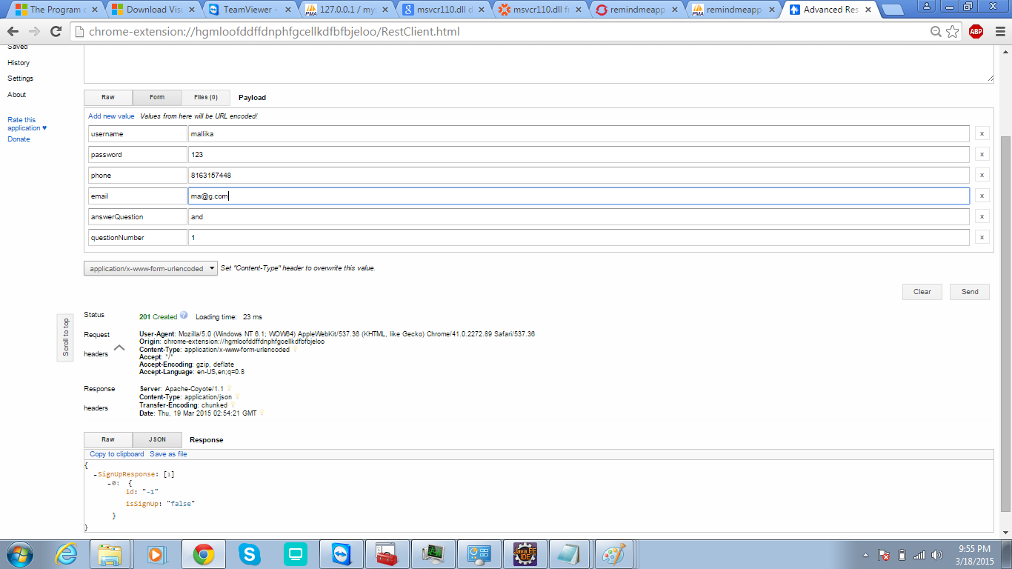

Shopping reminder -successful

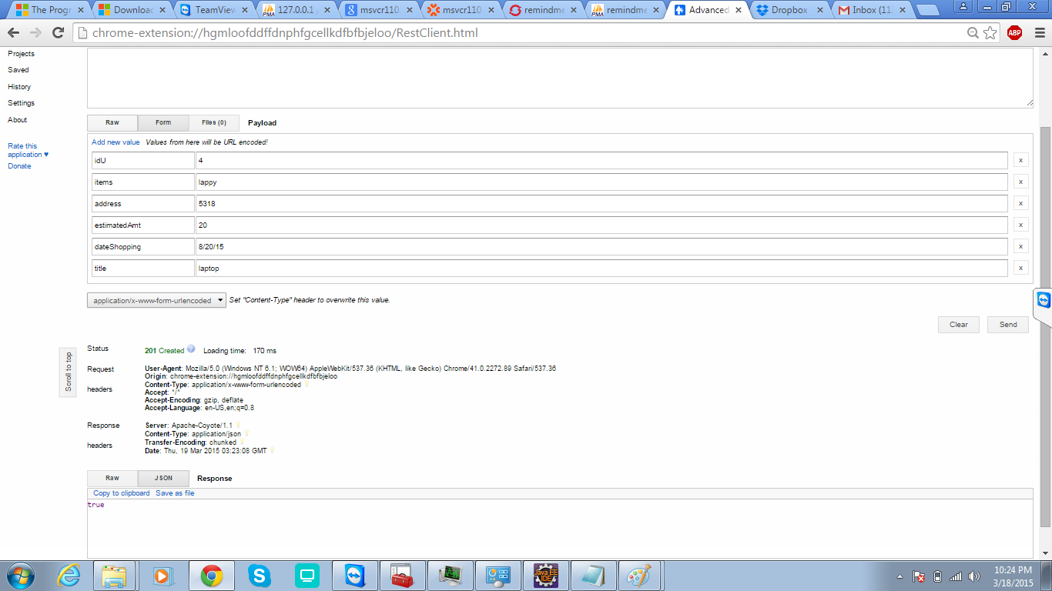

Forgot password- failed

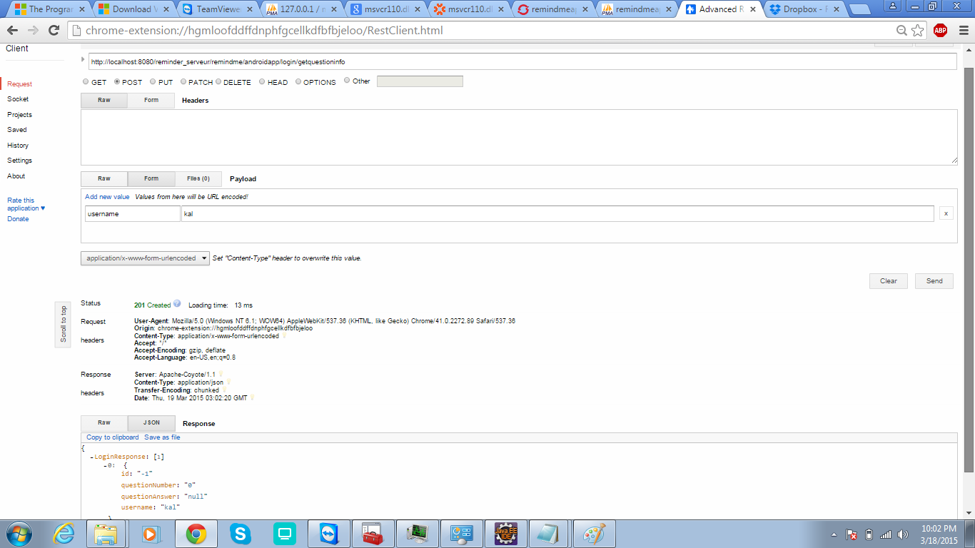

Forgot password- successful

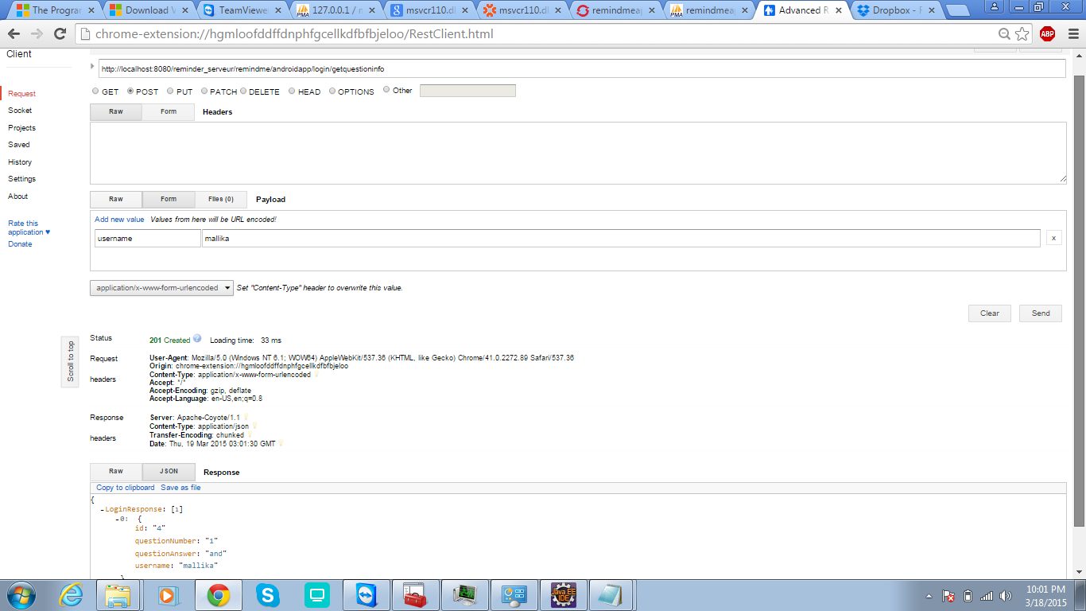

New password - failed

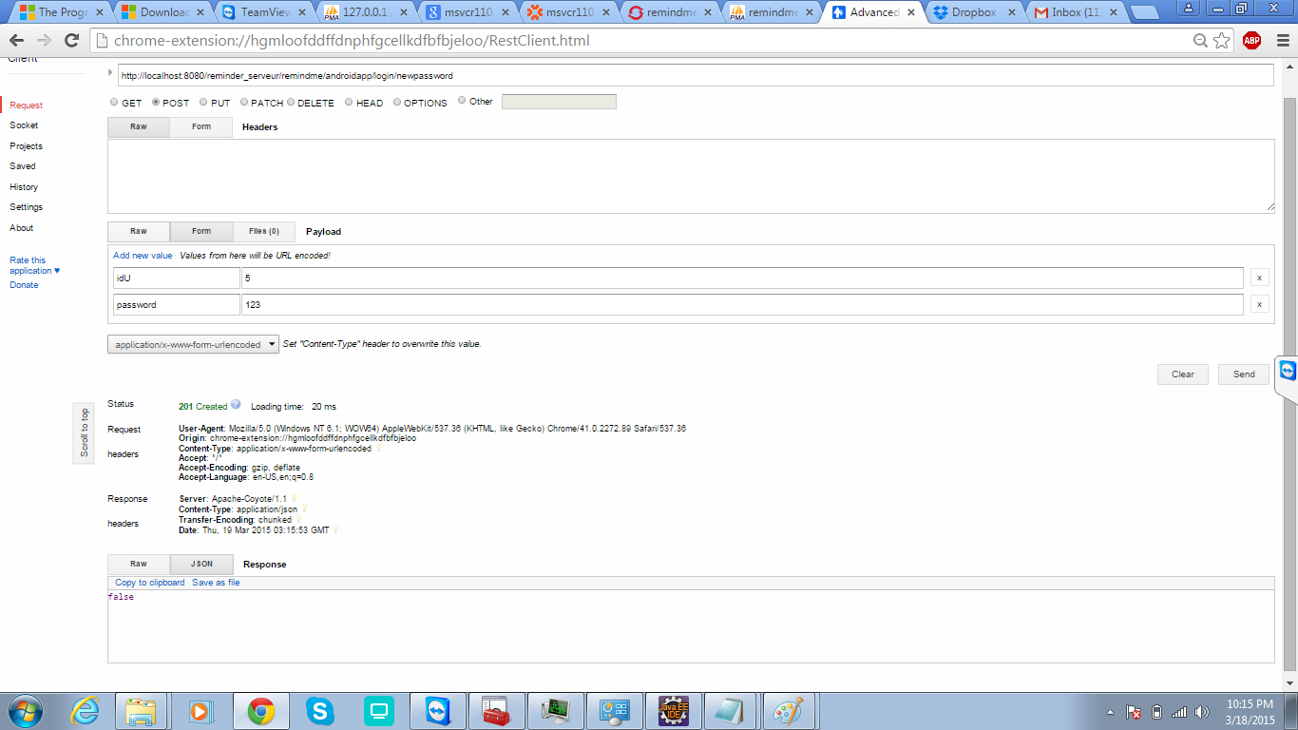

New password creation - successful

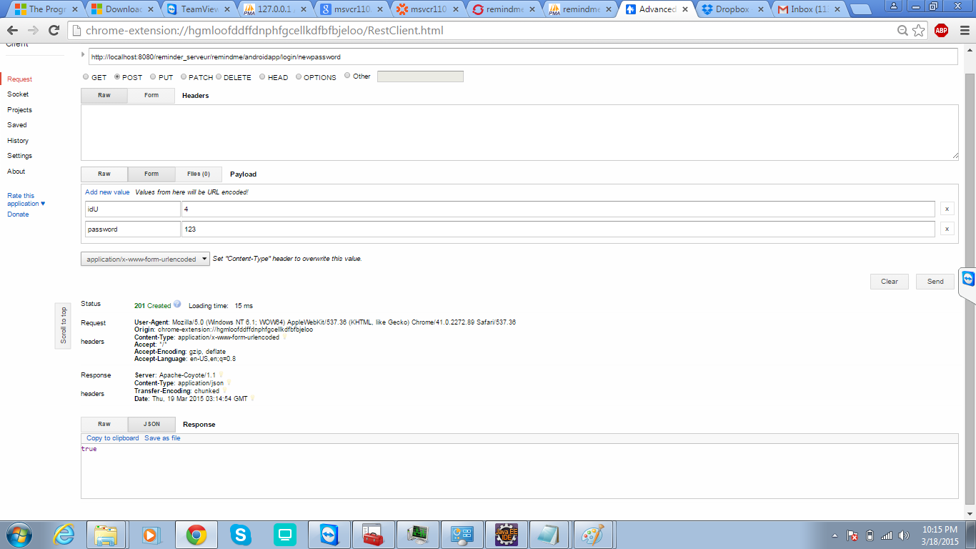

**Journey services:**

1. New journey reminder

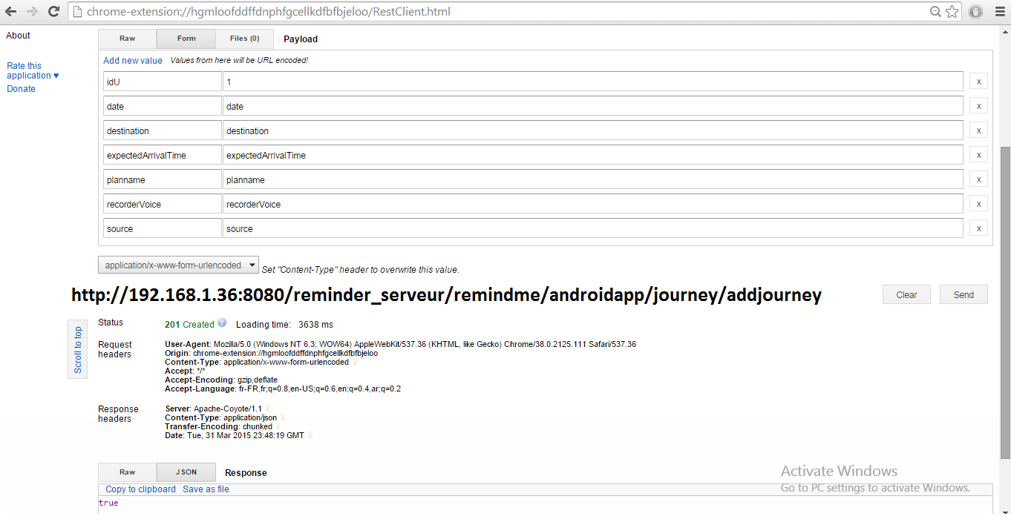

1. Deleting a journey: unsuccessful as id doesn’t exist

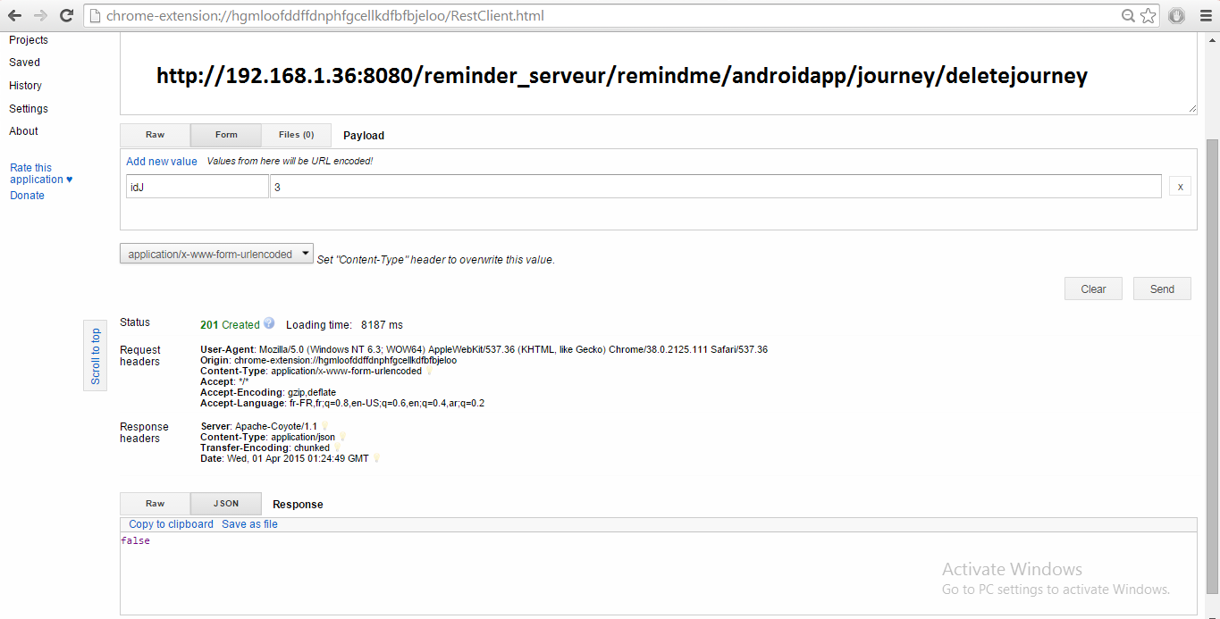

1. Deleting a journey: successful

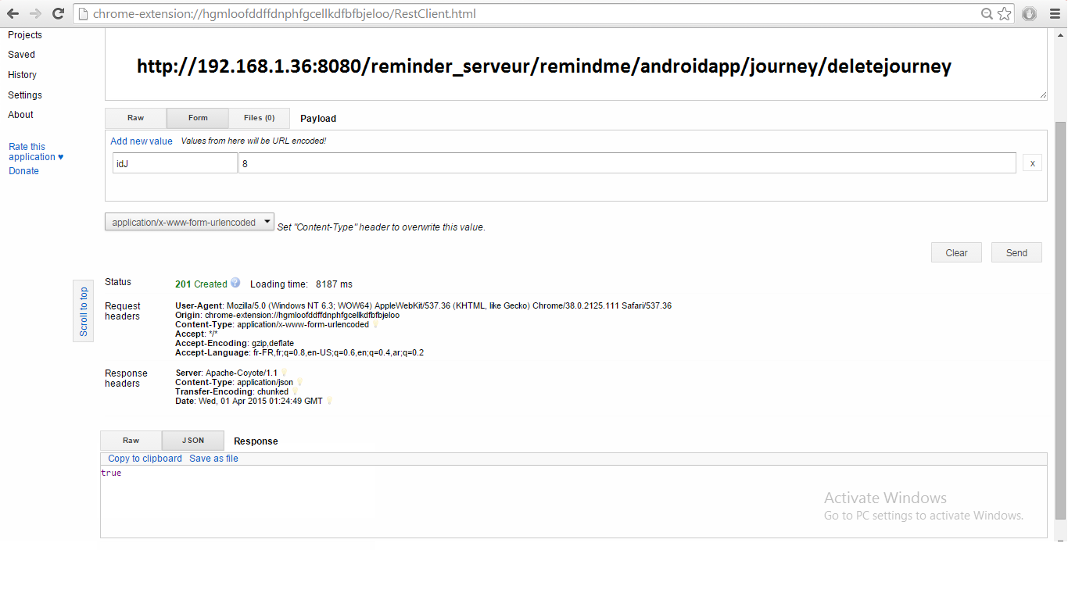

1. List of journeys added for a particular id

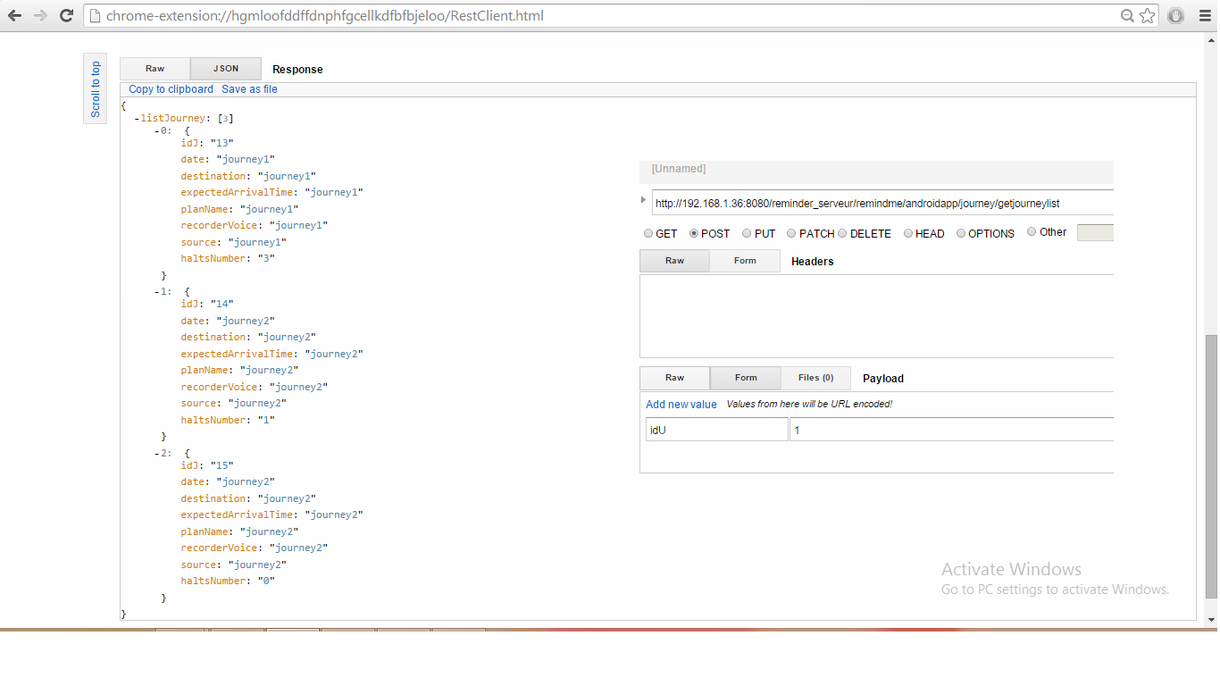

1. List of journey’s- if id doesn’t exist

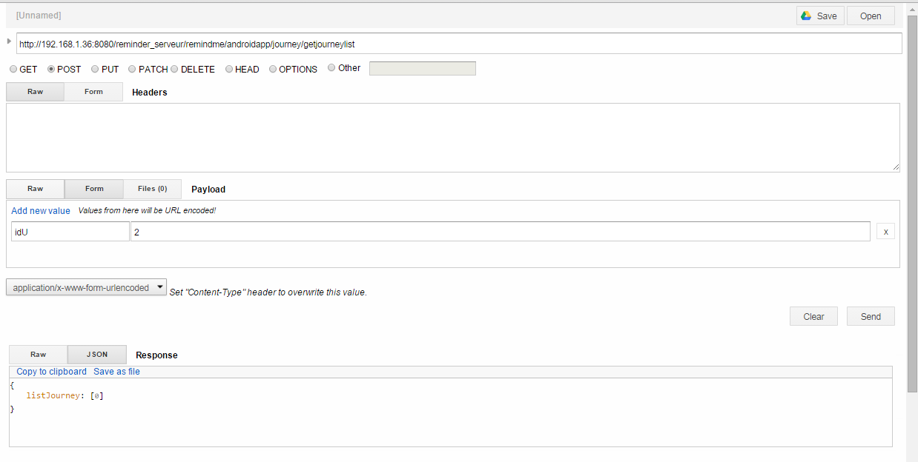

1. Updation of journey- not successful

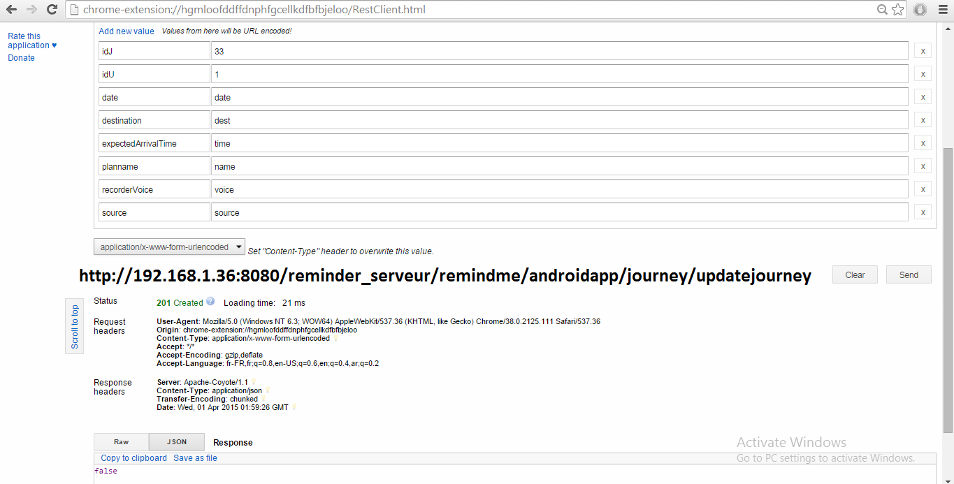

1. Updation of a journey – which is successful

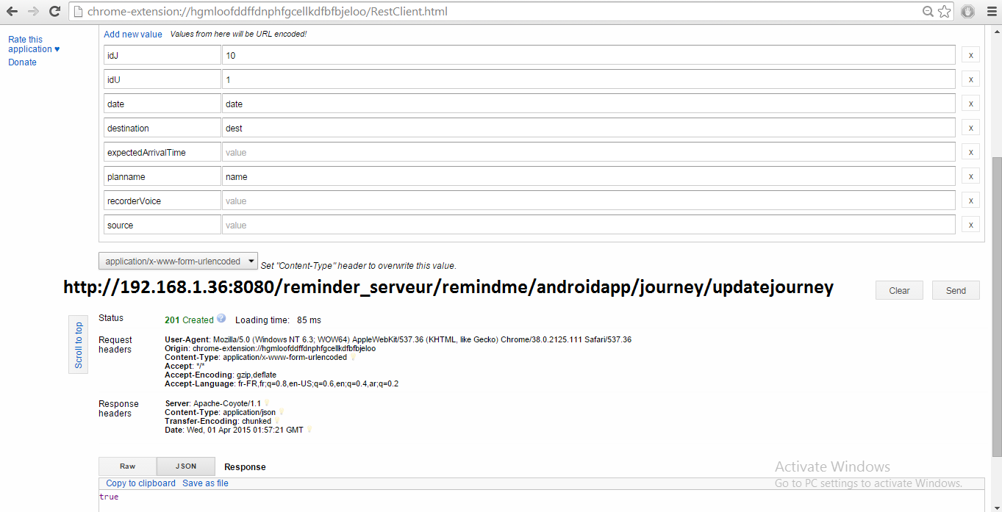

**Halt services:**

1. Adding a new halt by providing all the details required

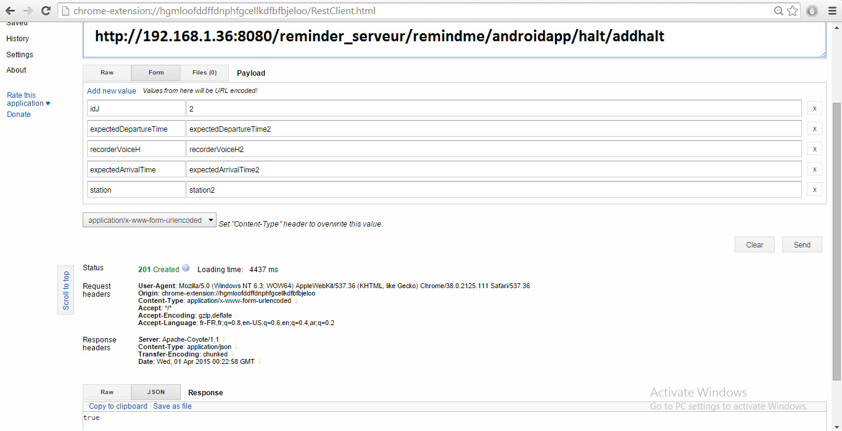

1. Deleting a halt – not successful as id mentioned doesn’t exist

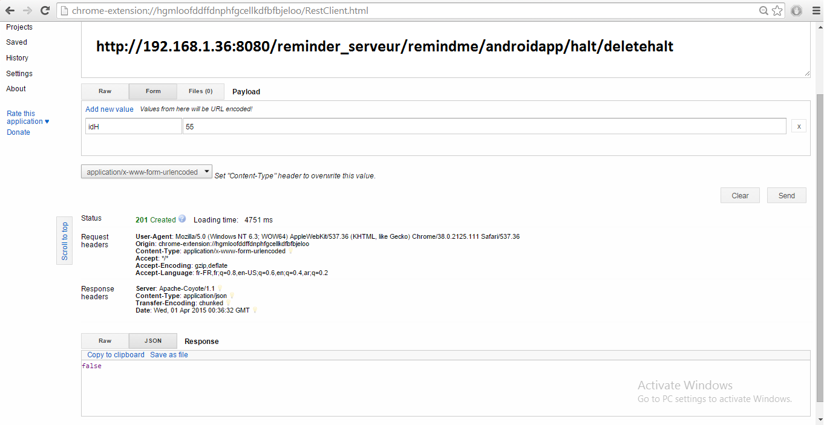

1. Deleting a halt –successful as id mentioned exist

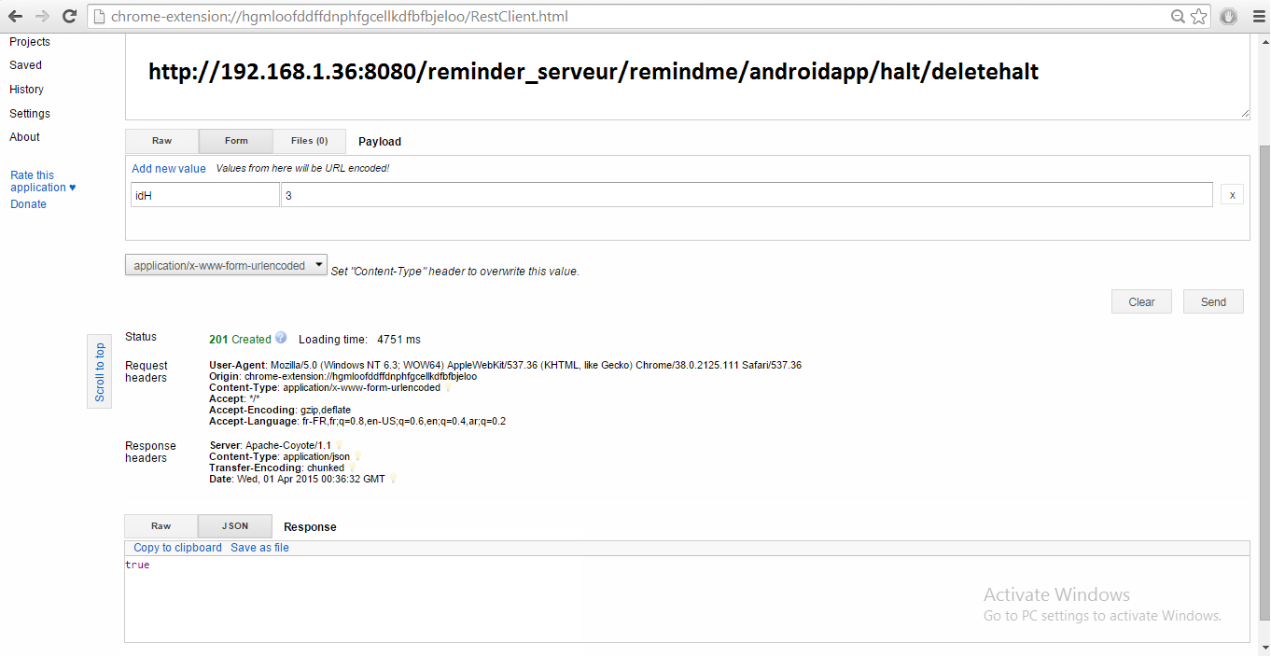

1. Getting a halt list of a journey with 3 halts

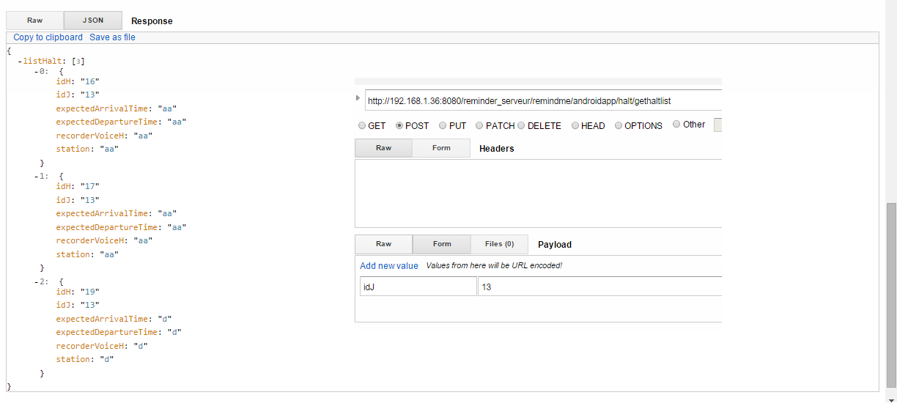

1. Updating a halt –not successful as information provided doesn’t match the database details

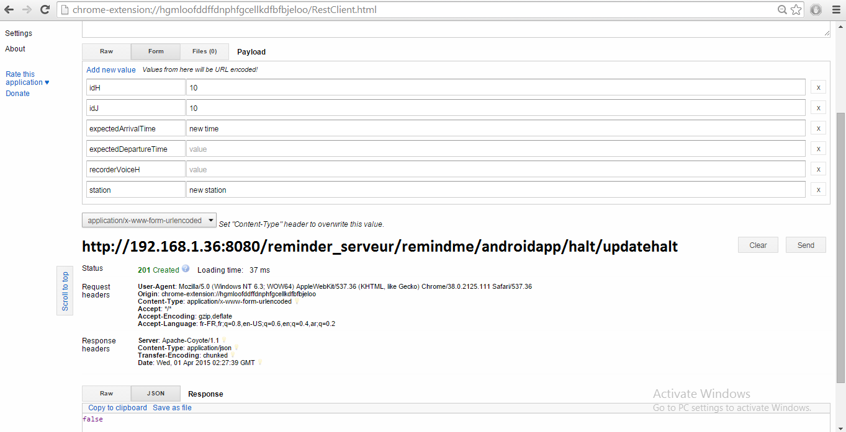

1. Updating a halt –successful

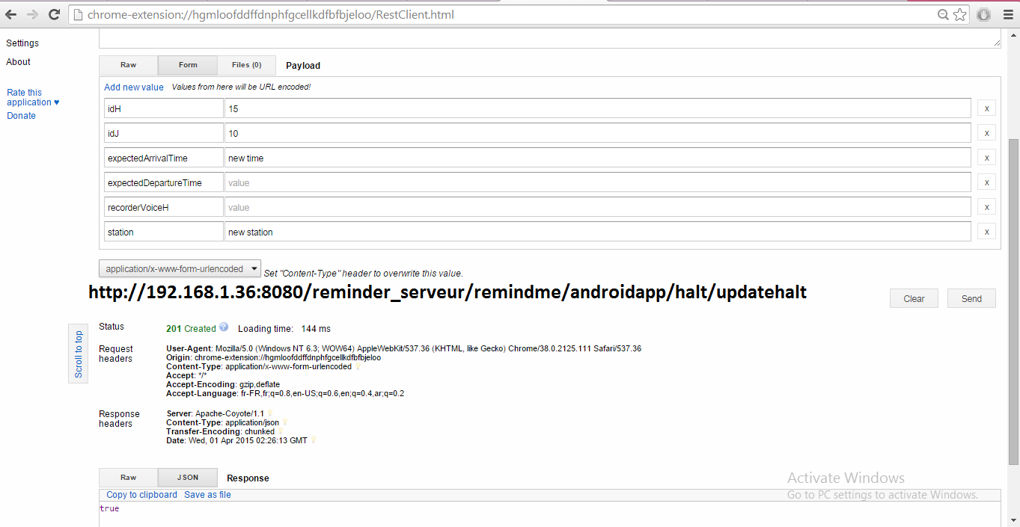

**PERFORMANCE TESTING USING DDMS TOOL:**

Android is provided with a Debugging tool called Dalvik Debug Monitor Server which provides the features needed for performance testing in case of memory usage by processes, Network usage by processes and some other information like logcat, thread and Heap Information.

Now examining these features using the DDMS Tool.

1. **Examining the processes for Thread Information:**

The thread information of a process selected can be examined by DDMS Tool like it gives information about how many threads running for that process. From selecting a process from many processes running like a process chosen here is “com.palreddy.remainder” and DDMS gives information about all threads in the process, thread ids, status details of threads, and also Utime and Stime of threads from where we can deduce the time taken by the thread and also the whole process to complete where as a whole it gives performance information

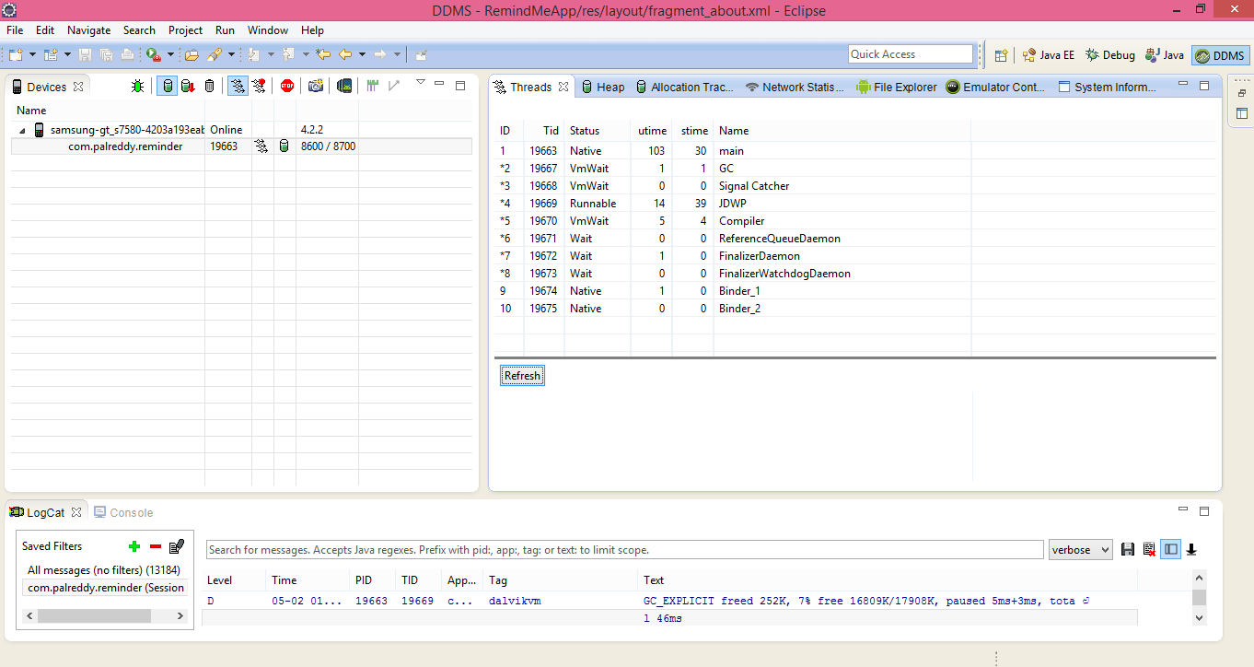

1. **Method Profiling**

To get the profiling information of a method, there is a need to use startmethodtracing() and stopmethodtracing() methods. This profiling information is useful for knowing certain metrics of methods like number of calls to the method and its execution time. For the profiling information, we considered journey tab and its methods for which we got the CPU time for the execution of these methods.

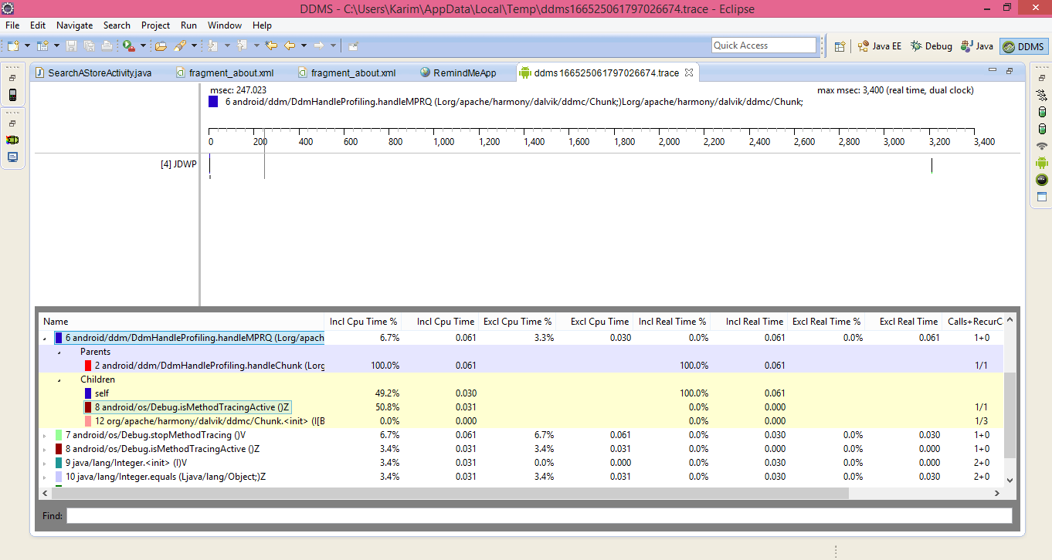

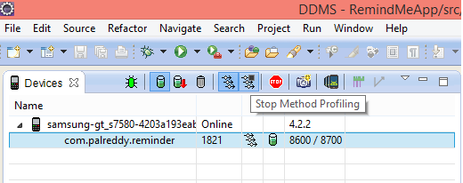

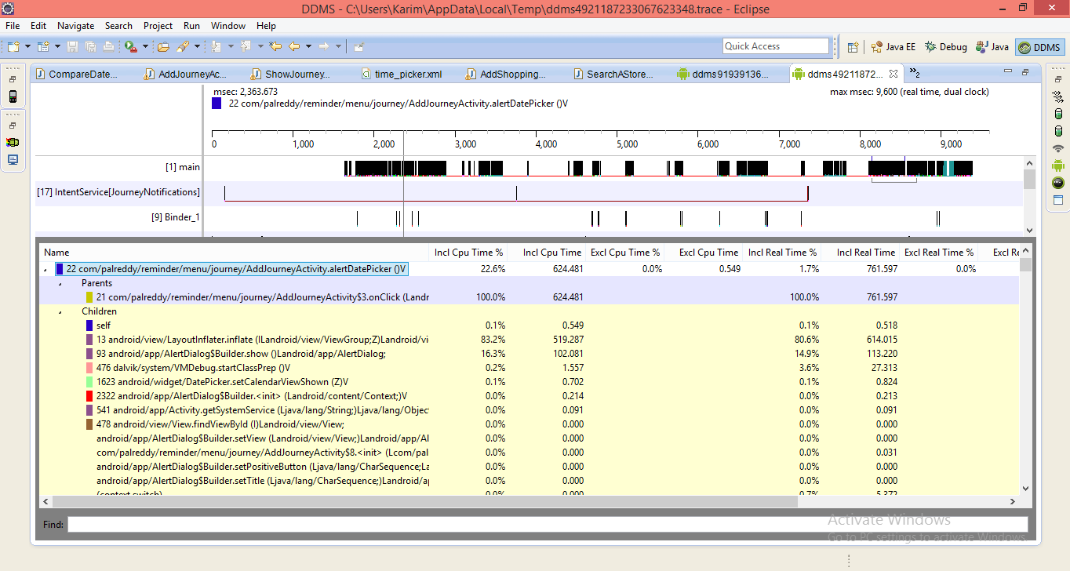

1. **Objects Memory allocation Tracking:**

The objects allocated in the memory of the particular class and thread information is available from which we can find the memory usage, and these are necessary to check the application performance.

Here the object tracking is performed on shopping tab and the memory allocated for this objects can be found between start and stop of the tracking button. More detail information is also available by checking the specific row and also gives the line in the code where these method exists.

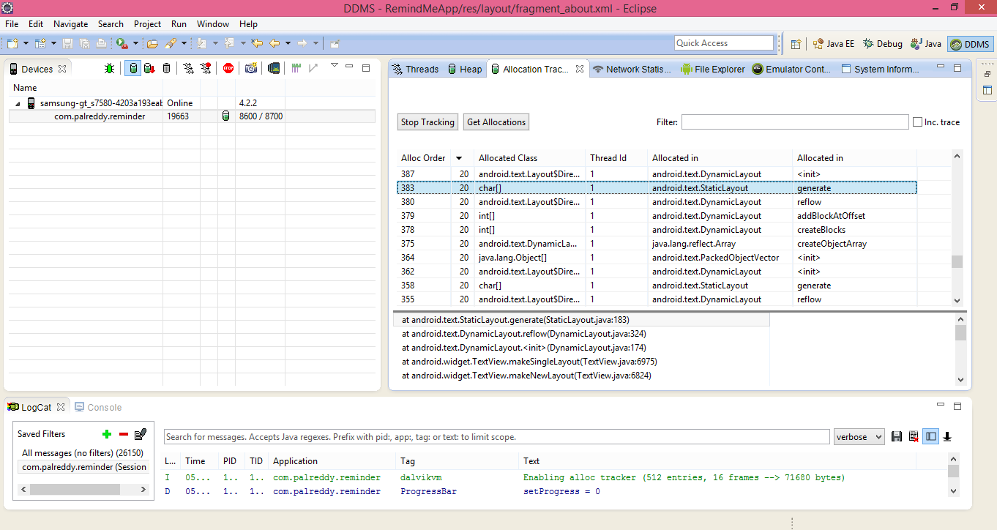

1. **LogCat usage:**

It outputs the messages in which we can find all the log information the same thing done by log class. When any exceptions are thrown it gives the stack trace details of that. Message outputs can also be filtered.

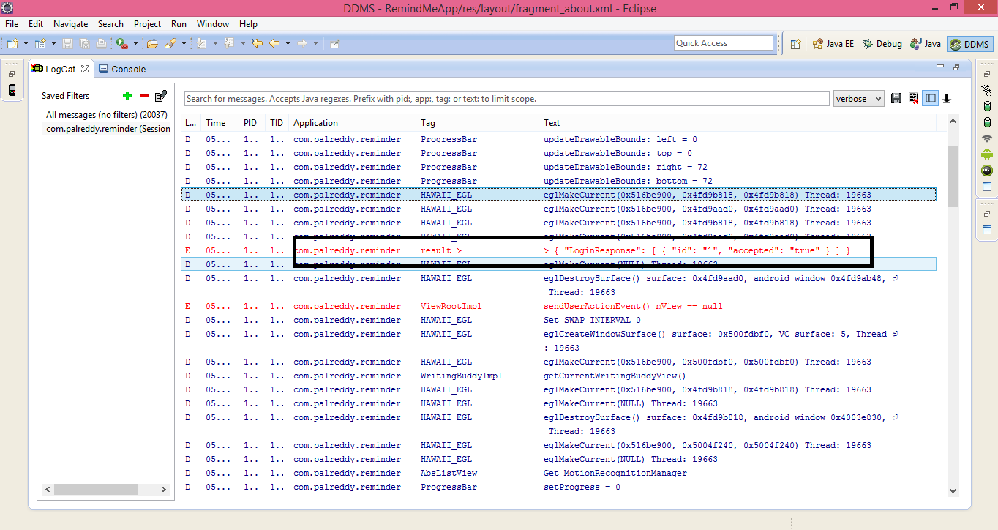

1. **Network Traffic Tool Usage:**

When a network request is made the network usage tab in DDMS will track the application. This information gives about the when app transfers the data, by monitoring the frequency of data transferred, the information is valuable to modify the app in giving more battery life.

Here we considered journey lab list, Shopping tab list and halt list to calculate their network performance.

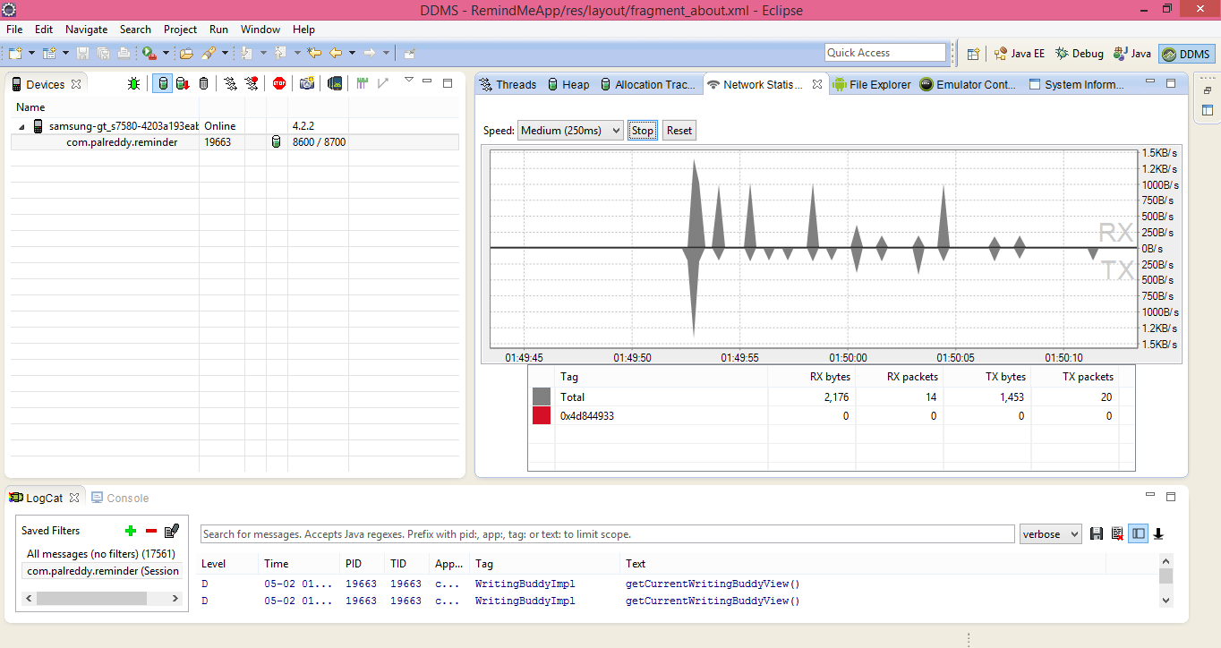

1. **Checking the process Heap Usage**

Heap processing test is useful to view the heap memory a process is using. This information is needed to track the memory usage during the execution of the application.

Here the test run on two processes, and obtained information about objects and memory allocated to those processes. Number of objects allocated for that memory size details also be obtained by checking the object type list. The information outcome is in terms of a bar graph. This is the performance details of app in memory management.

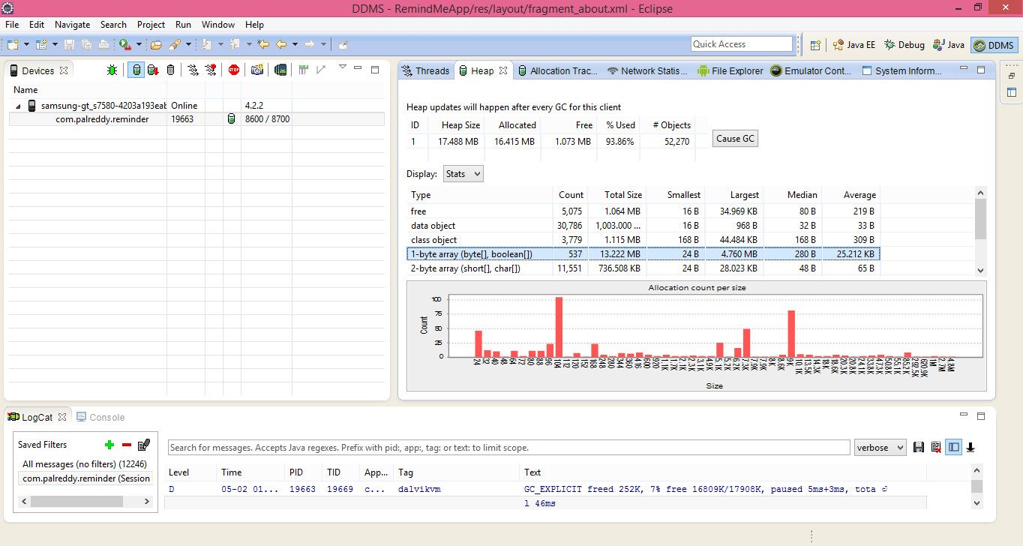

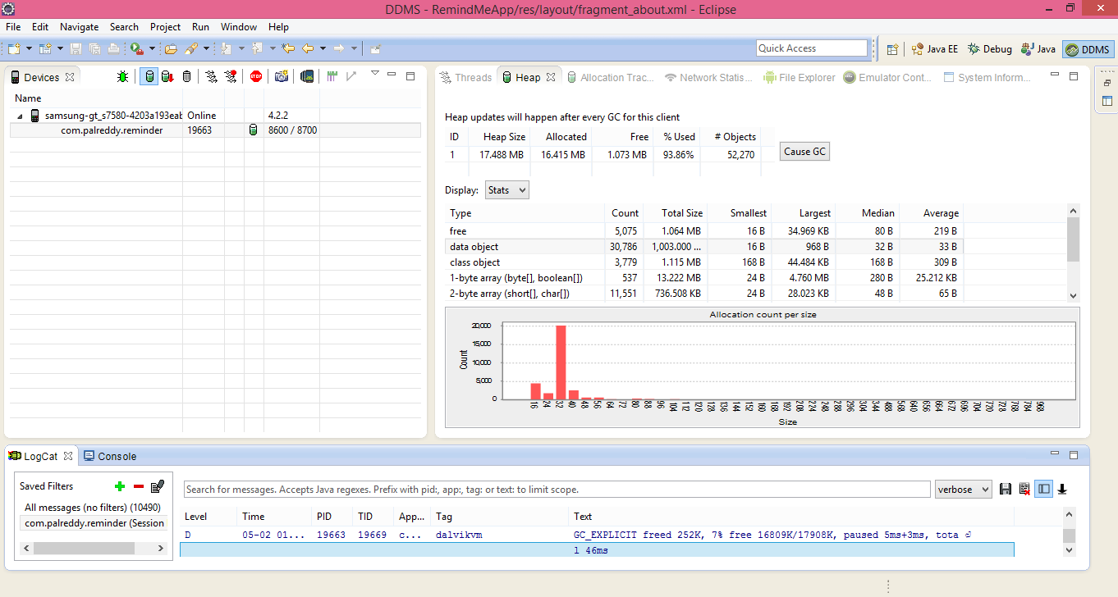

**Page Speed Insights:**

This tool is useful to optimize the performance of the website, it gives details about the page issues in the website and how can fix those issues.

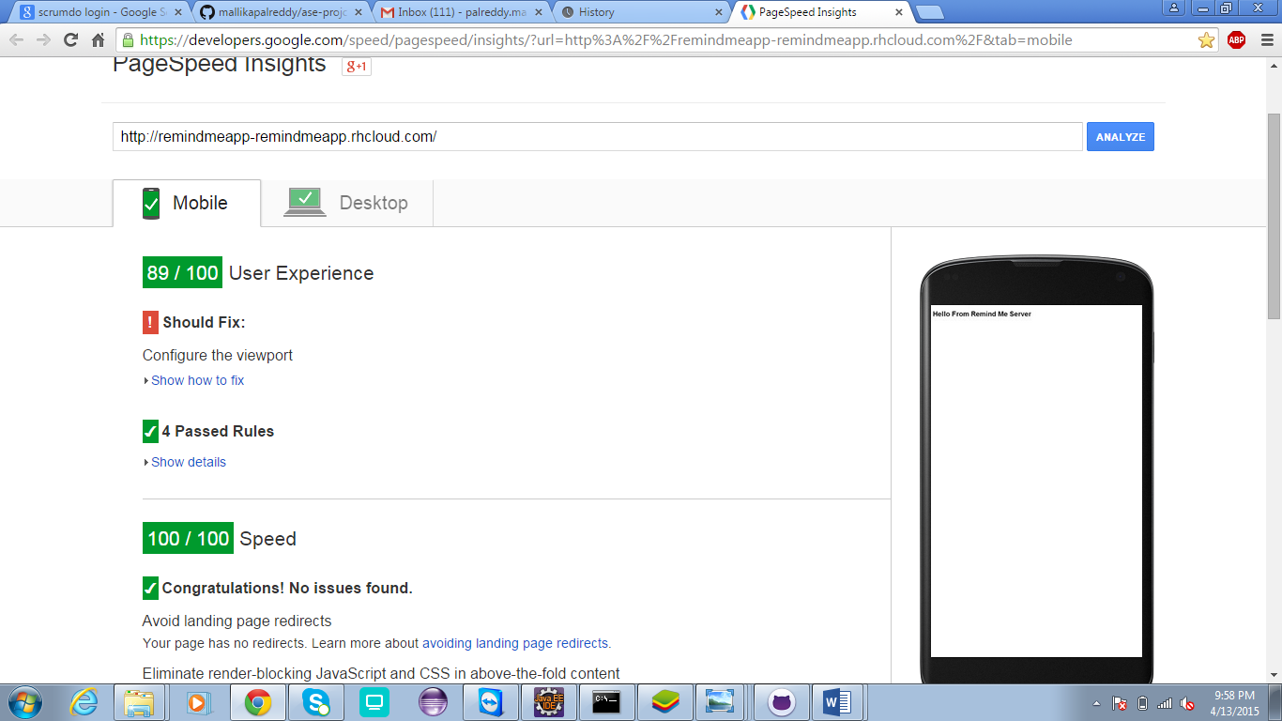

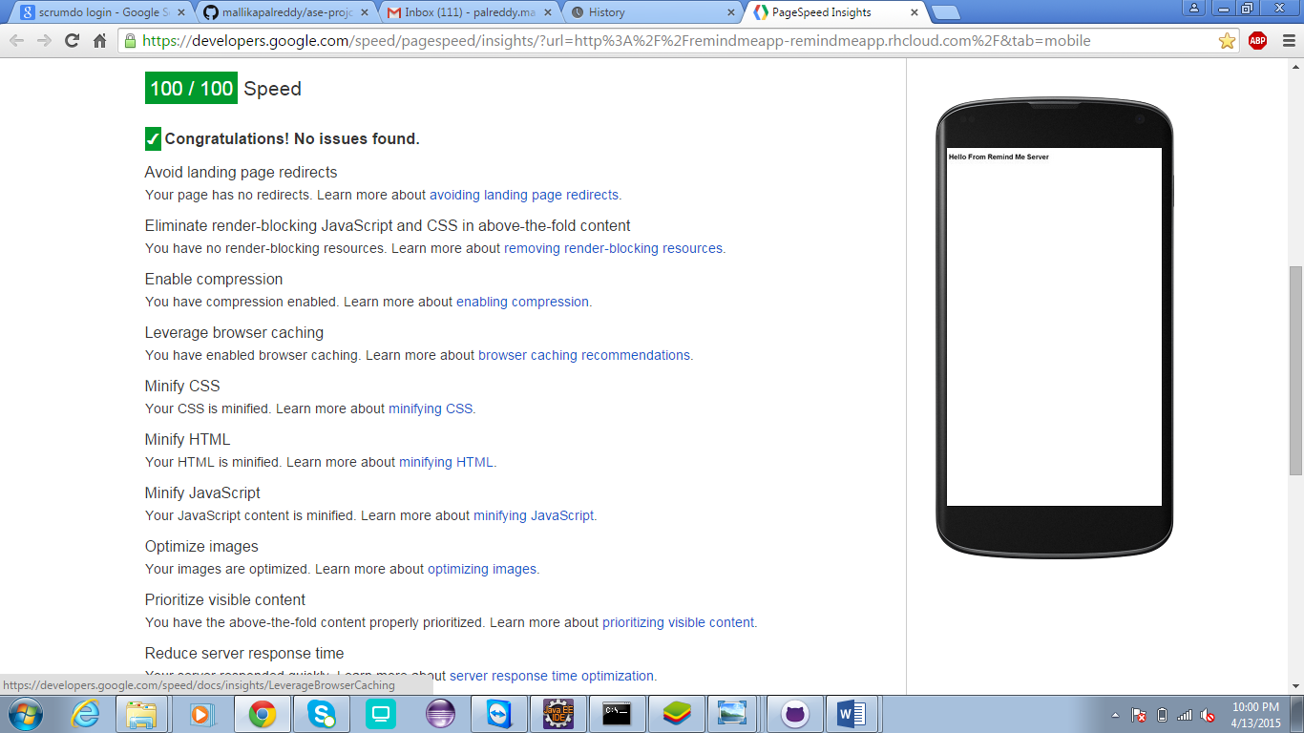

Scrumdo link:

<https://www.scrumdo.com/projects/project/remind-me/summary>

github link:

documentation:

<https://github.com/mallikapalreddy/ase-projct/blob/master/Increment-3-PG4.docx>

source code:

<https://github.com/mallikapalreddy/ase-projct/blob/master/RemindMeApp.zip>

youtube link:

http://youtu.be/fSo0Ej-51rk

By

Mallika palreddy (37)

Prashanth venna (51)

Mehaboob gori (54)

Venakat purnesh gaddam(16)